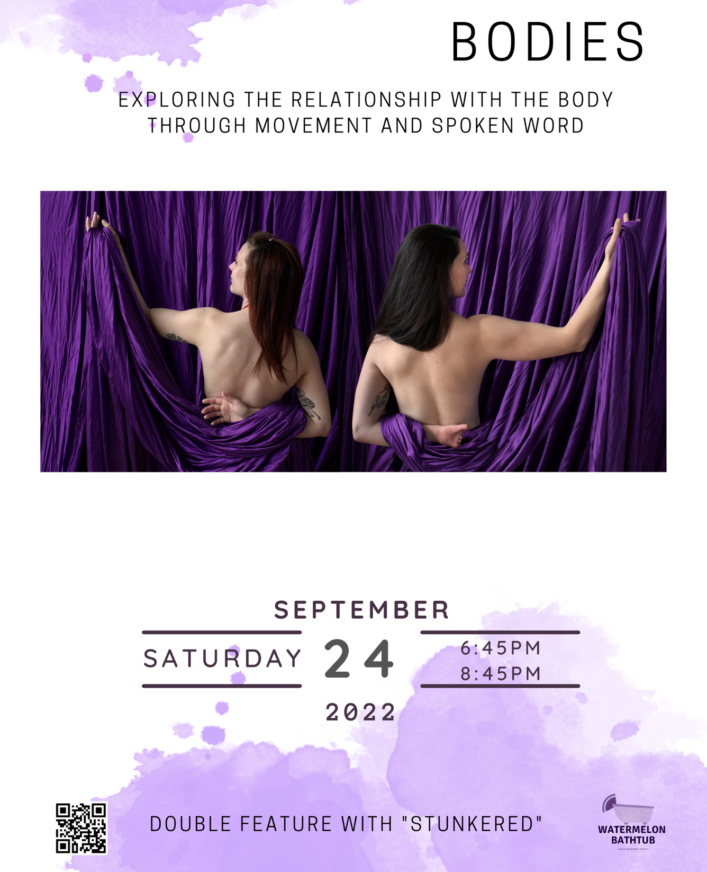

Bodies
a
Watermelon Bathtub

Production

Watermelon Bathtub is a Philadelphia-based theatre company.

Mission
To create impactful and accessible performing arts experiences with a commitment to showcasing artists and stories that are often untold.

About
Watermelon Bathtub Theater Company is based in Philadelphia and was created by two circus artists, Melissa Mellon and Sarah Tuberty. Using spin off of their last names embodying the curiosity and redefinition of terms that their work creates.
This production is hosted by the Circus Campus Hub
A part of the Philadelphia Fringe Arts Festival

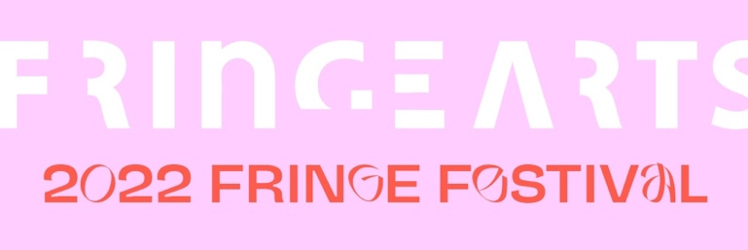
Image 1Fringe Arts 2022 Festival L

Access Notes:

- Wheelchair Accessible parking in the parking lot
- The gym is located on the first floor, there are 2 internal staircases to access the gym from the main floor.
- The gym can be accessed from the door by maneuvering over a grassy stretch and descending 5 steps down into the gym.
- Gender-neutral bathrooms on the main level (bathrooms are large enough to accommodate a wheelchair but do not have accessible height, sinks, or mirrors and do not have grab bars) Bathrooms are up 2 flights of stairs.
- Service animals are welcome.
- Masks are required indoors, mask breaks are encouraged.
- Water fountains are available, located up 1 flight of stairs.
- ASL interpreters available.
- Programs in large print, and an electronic version.
- No strobe or flashing lights during performances.
- Relaxed experience, movement is welcome.
- Touch tour offered 15 minutes before each show.
- Fidgets are welcomed
- Seating provided are the metal folded chairs, feel free to bring blankets, cushions, and pillows
- Matts will be available for laying and sitting on
- Accessibility table with access resources available.

Please provide feedback of your experience following this QR code or this link
https://linktr.ee/watermelonbathtub

Preshow Notes
This is a relaxed performance, movement, sound, and fidgets are all welcomed and encouraged.

There is an accessibility table with additional information and resources to help provide the pathways to access show content.

Seating surrounded the stage. The stage has 6 points where circus equipment is suspended from the ceiling.

The circus equipment we are using includes the following:

Lyra:
A large heavy metal hoop, suspended from the
ceiling. This hoop allows for a person to sit inside of it, and stand on top of it. There are span sets or, a type of rope, that connect the hoop to the ceiling. The hoop can spin around the point. The lyra is also called the aerial hoop.

Sling:
A sling is a large sheet of circus-grade fabric that is a vibrant color. This fabric makes a single very large loop, tying off at the attachment point. The fabric is soft, however, will become ridged when weight is put onto it. The sling can be used with all of the fabric bunched up together or spread out and a person can lay down in it like they are in a hammock. There is a swivel attachment that allows for the sling to spin. The sling is also called the aerial hammock, or aerial sling.

Fabric:
The fabric a large sheet of circus-grade fabric with two ends cascading down from the top of the rigging point. The fabrics are used by being wrapped around a body in various ties that someone unravels with the intention to allow for a drop. The fabric has an attachment that allows for the fabric to spin. Fabric is also called aerial fabric, tissues, aerial silks, or silks.

Stage Pole:
This is a pole that can exist freely in a space without needing an attachment to the ceiling. There is a large platform that the pole is inserted into and enables the pole to stand straight up. There is nothing on top of the stage pole.

Set Up:
The stage is set facing the northwest side of the gym. Starting from right to left will be: a sling, a lyra, the stage pole, open center space, fabric, and sling.

Director: Victoria Pirenoglu

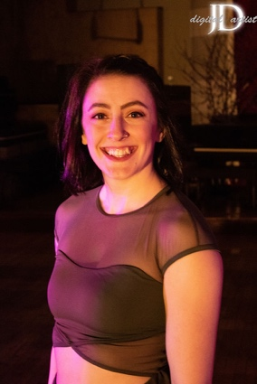
Victoria, (she/they) is a lover of movement from a young age and found circus at The Philadelphia Circus School of Arts in 2015. Building on a life-long foundation of hip hop and ballroom dancing, this discovery reignited her spark for expressing herself and telling stories through movement in the air.

Victoria is a full time circus coach at the Philadelphia School Circus School of Arts and performer. They have traveled up and down the east coast performing at places like The Muse, The Pool After Dark, and many others. She is excited to be working on this show and to give space to other performers!

“Bodie's is a show I have longed to see on the circus stage for as long as I have been in the circus. A show about people's experiences in their own bodies to different movement styles. Very often in the performing world we see the "beauty standard" that has been advertised to us on stage with little to no diversion in race, gender, body types and more.
Working with a diverse group of individuals to bring this exact show to the stage has been one of the most rewarding shows I have ever done. I hope this show moves you as much as it has moved me.”
Image 2 Headshot of Victoria, she is smiling at the camera

CAST

Aneeta

Performer and Storyteller

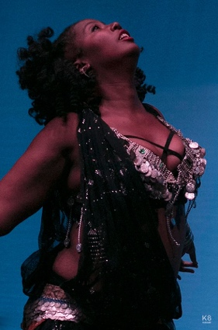
Aneeta (she/her) started bellydancing in 2001 with Najia and went onto study with June Seaney, Habiba, Kaeshi Chai, Oreet and Zoe Akili. She currently teaches at Mt Airy Performing Arts. She specializes in body positivity, teaching veil, cymbals and floor routine and assisting beginners in mastering the basics of the dance.

Image 3 Aneeta performing, she is dressed in belly dancing performance wear and her head is tossed up while engaged in movement

CJ

Storyteller
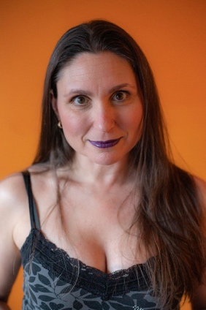
CJ (she/her) is an Australian disabled performing artist, writer, producer and advocate who has an acquired lower limb disability. She has been performing as a dancer, poledancer, aerialist and circus performer for over 40 years. At the age of 41 CJ became disabled overnight, losing both a lot of functional ability and her muscle memory from the waist down.

Due to the nature of her disability CJ has learned to expect the unexpected and adapt quickly when her lower half decides it just won’t comply, which can even happen on stage! CJ’s disability is generally invisible so for the past 7+ years she has grappled with how she is viewed and received by others as a performing artist along with having to learn to live with, accept, and love her unpredictable body. It’s not easy to let go of what we once were, especially when loss of function is viewed by many as a loss of talent. CJ’s goal is to prove that talent is not lost, it just shifts, and we can be and are as fabulous as we always were, or better.
Image 4 Headshot of CJ, she is looking directly at the camera, a vibrant orange background and her long hair falls to her left side

Casie Girvin

Performer and Storyteller

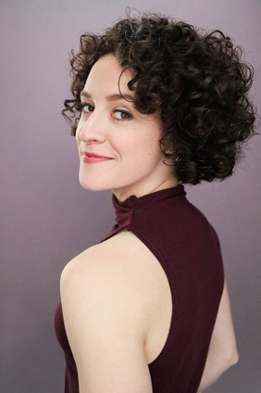
Casie Girvin (she/they) is a classically-trained soprano, actor, gymnast, and (very new, and learning) circus artist based in Philly!

She recently spent the summer training at The Actors Gymnasium in Chicago, majoring in static trapeze and acrobatics. Casie played the lead, "Dianne" in the pilot of TWO ANXIOUS BISEXUALS, which won 12 awards this year, including the Grand Jury Prize at the Film Invasion Festival in Los Angeles.

Other favorite projects include "John Webster/Acrobat" in SHAKESPEARE IN LOVE at the Capital Repertory Theatre, "Nellie Forbush" in SOUTH PACIFIC, and "Despina" in COSÌ FAN TUTTE. Casie is humbled and excited to bring the story of their body and medical journey to life, premiering the musical work of her partner, Steven Crino at this performance. Steve is a professional composer and educator based in Philly.
Image 5 Headshot of Casie, they are looking over their shoulder back at the camera and a confident smile on their face

Steven Crino

Composer

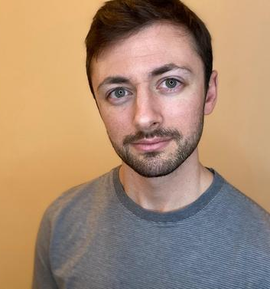
Steven Crino (he/him) sis a composer that seeks to write emotionally rich and intimate music that explores the murky intersections of conflicting emotional states. He often traverses feelings of nostalgia, melancholy, and a sense of yearning in his work. His music has been performed by ensembles and soloists, such as Peter Sheppard Skaerved, The Podcast Opera Company, The Boston New Music Initiative, The Philadelphia Experimental Theatre Ensemble, and The Temple University Singers.

Steven's first opera, Tomb of Beauty, is the third place winner of the 2021 American Prize, and his second opera, Friends House, was selected The Aural Compass Projects' Emerging Composer Competition. He has won other numerous awards including a 2022 Extraordinary Talent Award from the Rodrigo Landa-Romero International Piano Composition Competition, and was the winner of the 2018 3rd International A.D. Kastalsky Choral Music Competition. Steven received his Doctor of Musical Arts Degree from the Peabody Conservatory, where he also completed degrees in Composition (M.M.) and Theory Pedagogy (M.M.), studying with Michael Hersch and Kevin Puts. Steven currently resides in the Philadelphia area.
Figure 1 headshot of Steve, he looks into the camera with a slight smile

Julia Brandenberger

Performer

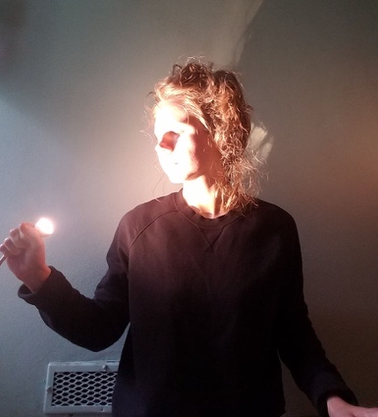
Julia Brandenberger (she/her) is a movement artist, clown/improvisational comedian and student of computer science and programming. She has an extended classical dance and experimental theater training and has recently moved her practice into the realm of pole and circus arts.

Her interest in religion and Jungian psychology informs the basis of her work and she often explores these themes through the lens of ridiculous absurdity. She is thrilled to be working with Watermelon Bathtub for the first time.
Image 6 Julia is looking to her right and towards a light she holds in her right hand. The light illuminates her face.

Shanay Williams

Performer and Storyteller

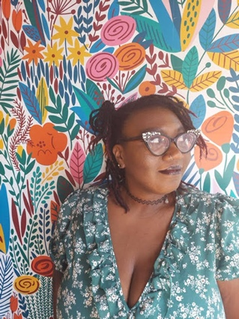
Shanay Williams (she/her)- you could say that community is in everything she does, by day she works in Public Health. Catch her in the afternoon? She will be coercing symphonic melodies from her cello; participating in local performances and charity events.

Never one to settle, Shanay then branched into a new hobby, aerials arts. What started as practice for movement has evolved into a performance expression that she is now ready to share with this community.
Image 7 Headshot of Shanay, she is looking off to her left and is wearing a floral shirt and is in front of a bright floral background

Amber Rambharose

Performer and Storyteller

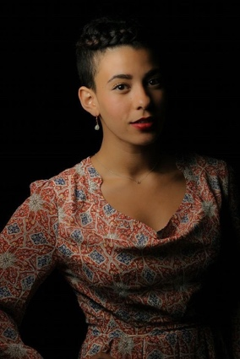
Amber Rambharose (she/her) is a Philadelphia-based writer and artist who has been studying aerial arts for three years and writing poetry for over a decade. Currently the beauty editor at Elite Daily, Amber spends her weeknights climbing silks at the Philadelphia School of Circus Arts and her weekends writing poetry and fiction. Her poetry and lyric essays appear in Linebreak, Rattle, PANK Magazine and Tupelo Quarterly, among others.

Her creative work, including the piece she is performing in the Watermelon Bathtub “Bodies” show, explores the relationship between self and body in the context of generational trauma and the strange alchemy that often occurs through the act of surviving.
Image 8 Headshot of Amber, she is looking at the camera with a slight smile

Melissa Mellon

Performer, Storyteller, and Co-Producer

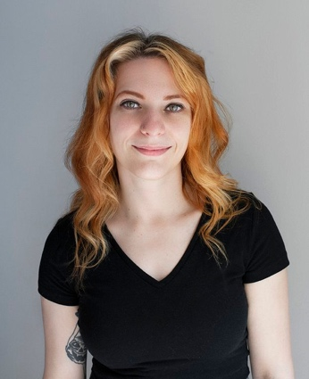
Melissa (she/her) studied Theatre Performance at Juniata College, where she trained in acting, movement expression, Skinner Releasing, Fitzmaurice Voicework, and was introduced to single point trapeze. She finally made her way to training at the Philadelphia School of Circus Arts where she is now a youth and adult coach.

Melissa is skilled in aerial arts on the lyra, trapeze (single and double point), pole, lollipop, and sling. She is also trained in fire flow and safety. She is available for aerial bartending, as well. Her favorite thing to do is create beautiful flying and ambient acts.
Image 9 Headshot of Melissa she is looking at the camera and smiles confidently

Sarah Tuberty

Performer, Storyteller, and Co-Producer

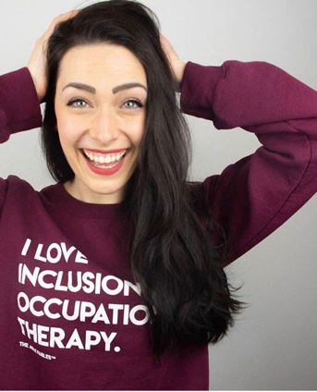
Sarah Tuberty (she/her) studied Occupational Therapy at Boston University, and is in a PhD in Occupational Therapy program at Texas Woman's University.

Sarah has studied and trained in accessible aerial arts, and has a particular interest in the psychosocial impacts of disability and disability identity. Especially in spaces where the disability narrative is so often told from individuals outside of the disability community. Her work is to showcase stories and perspective of the authentic disability narrative.

Sarah has trained internationally in the lyra, fabrics, pole, and trapeze.
Image 10 Headshot of Sarah, she is smiling wide, looking at the camera and has her hands on her head

Bodies Partners

ASL Interpretation: PRO BONO ASL
Pro Bono ASL is made up of both hearing and Deaf American Sign Language interpreters. We are Interpreter Training Program students and graduates, and community-raised interpreters. We are Black, Indigenous, Latinx and People of Color along with white allies. We are full time interpreters and lifelong protestors. We provide ASL access pro bono, as well as professional interpreting services and community support.
Image 11 PRO BONO ASL Logo

Website: ProbonoASL.com

Videography: Danie Harris

As a filmmaker and photographer, Danie specializes in documentary, music video, and narrative-driven film production.

As a director, Danie relies heavily on her previous experience as a dancer and choreographer to inform her work.

Outside of film and photography, you can find her at a circus class, knitting a sweater, or heading out on a climbing or cross-country skiing road trip.

Website: danieharris.com

The following is a collection of access elements, the transcripts of the audio and a general written description of movement in show order.

Shanay Williams

My Body Takes Up Space
Narrative  Description: Shanay identifies as a black plus size femme with large black and diamond cat eye glasses with purple and black hair. She will be performing on the aerial sling. She will be wearing a purple lace body suit with black tights.  Content Considerations: Piece discusses body image and reflections.  Song: Lunar Rhapsody, Dr. Samuel Hoffman & Les Baxter.  Spoken word: Shanay recorded her own voice.  Begin:  My Body  My Body is curve  My Body  My Body is mine  My Body is strong, and it supports me  It holds me  My Body is Strength  This Strength that carries me through every day  Its Grace  I should give my body the grace it deserves  And take up space  I will not shy away  I will show my strength and grace  I will be proud of my curves  And appreciate what my body does for me  While I’m in the air  I will show what body can do  I will show the world the strength t the body has  And not be ashamed. | Movement description  Begin:  Shanay lays on the ground on her back,  She moves her arms in a flowy motion while laying on the ground  Shanay now rolls into a shoulder stand and hold her lower back with her hands. She waves her legs in the air  Shanay rolls back to the ground her hand follows her leg to her foot  Shanay now stands up and looks at the sling  Shanay puts the sling being her and begins to swing  She then puts one leg up and spins faster  She then grabs up high on the sling and pulls herself up  Shanay then moves her leg through the sling, and is now in upside down stag. She then hooks her leg on the sling and sits in upright position.  Shanay then lower herself by rolling through the sling. And making a crescent shape in the air.  Shanay’s feet touch the ground, and she leans back her in sling.  Shanay then begins to spin in her sling with the sling under her arms and inverts into a gazelle shape  She ends the performance spinning in her sling

Aneeta

The Body I Inhabit
Narrative  Description:  Aneeta is an African-American plus-sized bellydancer. Her act will include slightly improvised sword balancing with a focus on body positivity.  Content Considerations: Her act will include slightly improvised sword balancing with a focus on body positivity.  Song: Ou Est Ma Petite Danseuse (Where Is My Little Dancer) by Gypsy Caravan.  Spoken word: Aneeta recorded her own voice.  Begin:  Although there are many plus sized belly dancers, I always have a moment of panic as a woman of color outside the ideal size before I perform. Will I fit into the audience's idea of a belly dancer? Will they be disappointed if I am not thin enough or my skin is too dark and demand a refund? When I was 29, and in an upper state parade, a group of teenage girls surrounded a plus sized troupe member and refused to believe she was a dancer.  Although I love serving as an example to my students that belly dancers come in all sizes and all colors, I can't stop comparing myself to size zero professional dancers and their ability to maintain that weight as the pounds pile upon mine. Sometimes before teaching, I typically layer 2-3 tops for maximum support. When I initially grew in size, I wore a belly cover - either a chain or see through girdle or full body gahwazee dance coat to hide the weight. After failing to find a costume at a bellydance festival with plus size sellers, I gave in and commissioned a new one. The costumer complained about making a costume that large after payment.  One of my incredibly thin students told me she couldn't perform because she didn't have the body of a bellydancer. I asked if she had ever seen any professional belly dancers. She said no. I asked if she felt anyone in the room, including myself and the other instructor, fit that body stereotype. She said no. Even after I listed numerous plus sized dancers, she still insisted, that she herself did not have that body and could not perform.  Sometimes people commit offense without meaning to. While teaching for a library workshop, the coordinator swapped out my PR shots for that of a thinner Caucasian dancer. Every now and again fellow dancers or students will emphasize their thinner weight compared to mine. When teaching in Mt Airy, an older Caucasian student could not believe I was the instructor despite my choli, boombox and headless mic.  So this is why I continue. Even though I'm no longer 20, no longer 130 pounds, do not wear long, straight hair and have never had light or white skin. At every venue I perform, for those outside the dance community, I introduce a new concept, a real concept. Not one grounded in 1950s films and cis het white male ideality but in reality and in the skin, the color, the form, and the body I currently inhabit. | Movement description  Begin:  Aneeta attempts to balance the sword on her head while shimmying.  Aneeta executes a series of turns, undulations and figure 8s.  Aneeta sinks to the ground to her knees and executes kneeling undulations within a circle while balancing the sword on her head.  Aneeta will attempt to do a reverse plank on the ground with stomach undulations while still balancing the sword on her head.  Aneeta will possibly add a second sword and balance on her chest.  Aneeta will either raise to her feet with both swords and end in a pose or remain on the ground and pose with both swords.

Amber Rambharose

Love Your Difficult Self
Narrative  Amber: Amber identifies as a biracial woman. She has brown skin and long, curly brown hair. Amber performs on the fabrics.  Content considerations: Discussion of trauma and body harm through seasonal metaphors.  Song:  Spoken word: Amber recorded her own voice  Begin:  I've lived here longer than three decades, but I am still a stranger in my body.  I still need a map to find sleep  An alarm on my phone to ring  hungry because I never quite learned how to eat or meet my own needs.  And I often give up in the middle.  My body has learned, I only give it what I think I deserve and that's very little.  This body of mine  I have salted it's soil because sometimes what it does makes me feel so strong and special and then other times  it leaves me undone.  Every time, my heart races and my mind can't keep up every fight or flight frenzy when I'm flinching or freezing.  Every time I start crying when I want to stay calm.  Every time any calmness eludes me.  Then I hate it here  And I want to go home  To a better one.  Less prone to bruising  a home with an alarm system that's actually working.  A home full if dopamine and serotonin  Where every emotion doesn't cause a flood in my brain that I drown in.  This happens so often that there are water marks and salt stains on the backs of my eyelids.  This body is always exhausted.  Always vigilant and fearful.  Every compass here points to survival and I couldn't find happy if you took my hand and showed me the path.  This body would orbit me right back to being terrified, waiting for the tide to wash in some threat unidentified but harmful.  It gets so lonely on this storm-born Island that sometimes I forget the way it started.  This topography of jagged pain responses, my body has never forgotten.  It remembers things that only come to me in dreams I wake up from with blood in my mouth because I've clenched my teeth so hard they cut my cheeks.  My body won't give back those memories.  And forgives me the taste of pennies in the morning.  It forgives me for, at 17 falling in love with my rib cage, without warning spending the next 10 years of starving, Until I became just water with a bedsheet thrown over a surface for my bones to float up to and press against it  And again, my body for gave me the dangerous men  for believing neglect was the bed I slept best in.  For trying to breathe through my skin.  My body forgives it's constant excavation  for the fires I set inside of myself for burning every Garden down.  Because I never believed I was worthy of roses.  I am.  And my body knows this.  And I still can't quite forgive it.  But I am trying to forgive my body. It's surviving for every time I've given up and my lungs just kept on breathing.  Each time I tell myself, I'm nothing my body tries to show me “Look”  After a forest fire nutrients from dead trees feed their seedlings siblings  And there is a plant in the spike Moss family that can survive for years without a drop of rain.  Soil is more fertile after being struck by lightning.  It takes a star of a billion years to die.  And even after, it keeps shining.  And if M-Theory is to be believed and pressed close to this galaxy is another one, where the Earth we live on isn't dying.  When I can't fall asleep  When I'm too sad to eat  When I am floating body whispers somewhere.  it's still snows and it is snowing and there are crocuses unfurling.  Somewhere there is a you that wasn't called so early.  A you that grew up smiling somewhere.  This body is glowing and that possibility means something  it's still could happen here.  Watch close  right  now.  It's happening. | Movement description  Begin:  Amber sits between the fabric. Slowly, she raises one hand and then the other to grip either side of the fabric  She twists her hands into the fabrics and slowly lowers them. Suddenly, she releases both fabrics and steps through.  She turns and faces the fabric and grips either side in both hands.  Amber inverts between the fabrics with her knees to her chest.  Spinning, she brings one leg between the fabric and poses.  She begins to climb.  She spins.  Spinning, Amber inverts between the fabrics and double-crochets her legs.  She reaches her arms down and holds the tails of the fabric.  She twists the fabrics behind her back.  She folds her body into a ball.  Amber holds both legs in front of herself and wraps one end of the fabric around each foot.  Amber spins.  Amber flips into an upright position, releases her legs, and spins.  Amber climbs the fabric.  Amber turns her body to one side into a hip-key position.  Amber spins, wrapping the tails of the fabric around one leg.  Amber pushes her torso through the middle of the silks, poses, and hooks one knee over her head.  Amber shoots out her leg and climbs above her hooked knee.  Amber poses with both hands over her head, gripping the fabric above her with both hands.  She lets go of the fabric behind her and dives forward into a 360* dive drop  She holds on to the fabric above her head and waves her legs to unwrap the fabrics  Amber gathers the fabric tails between her feet and begins to climb again  Amber folds her body into a hip-key position and spins herself  Amber pushes herself through the fabric and poses in a back balance position  Amber drops the wrapped fabric off of one leg and brings the other leg through the middle of the fabrics  Amber poses with one knee bent in the fabrics.  Holding the fabric in both hands, Amber lifts her body into the air, inverts between the fabric, folds herself into a hip key position, and spins.  Amber brings one leg around the fabric and, holding the tails in one hand, poses.  Amber spins.  Amber lets go of the hand holding the fabric and does five front flips, holding the fabric in between each flip and threading her leg through.  Amber climbs down.

Casie Girvin and Steven Crino

Through Hoops
Narrative  Descriptions:  Casie: Casie has short, brown, curly hair, female presenting, she/they identifying, white, athletic/petite build. They perform on the lyra.  Steven: Steven has black hair, male presenting, medium build, white, playing piano.  Content considerations: Piece explores harmonizing with piano. There are 4 loud sounds on the piano  Sound: Casie harmonizes in haunting sounds while Steven plays an original composition on the piano  Begin:  Pianist plays off the audience’s right of the Lyra  High, uncertain vamping sound in the piano  Loud BAM sound in the piano  Repeated vamping sound in piano, soprano starts singing haunting “eeee-oooo”  Loud BAM sound in the piano  There is a sound between the voice and piano that sounds like pushing and pulling, almost wave like, but spookier  Loud BAM sound, singer sings: lower notes “ahhhh”  A rolled chord on the piano, singer sits up and sings, with a more hopeful feeling, and higher in their register “ahh”  Atonal, chaotic piano solo  Singer sounds defeated again, singing a pattern of chromatic notes in the middle-low part of her register  Loud BAM sound in the piano  Soprano repeats the last note of the song | Movement description  Begin:  Pianist plays off the audience’s right of the Lyra.  Soprano/Aerialist walks up cautiously to the lyra  She gets on the lyra and swings openly.  With a loud “BAM,” she drops into a single knee hang  When she starts to sing, she climbs up to sitting, then inverts on the higher part of the lyra, to sitting on top.  With a “BAM” she does a straddle drop in the Lyra  The soprano hangs inverted in the straddle drop for a while, singing.  With the next “BAM” she does a panda drop from the high part of the lyra to the lower part on her stomach and hips, and stays in a hip hang for a moment.  The singer climbs up to man on the moon position and sings, appearing perhaps more hopeful for a moment.  When the piano becomes more chaotic again, the aerialist splits away, beats 3 times, and shoots backwards through the lyra to a front balance.  Reaches out in a front balance, and with the next “BAM” does a front hip circle, dropping into a straddle.  She pulls one leg out to a split, gets back into the middle of the lyra via russian roll, and perches while she sings most of the rest of the piece, until the last 2 repeated final notes, where she slides back to a knee hang, defeated.  She drops one knee and ends in a single knee hang.

Through Hoops Program Note:

What does it take for us to listen to our bodies beg us to stop, take a break, relax? Society conditions us to push it all down, not listen to our bodies when we need to step back. This was even something I prided myself on: I could push through anything, and force my body to keep going until I let myself only crash once I was in bed for the night. This all changed in November of 2019, when my body pulled out all of its’ stops, and forced me to listen.

I couldn’t get through an hour of my day without having to lay horizontally. I had excruciating abdominal pain, headaches, and overwhelming fatigue. After finally realizing that I needed help, and several tests later, I was diagnosed with a tumor on my pituitary gland in my brain 2 months before the start of the pandemic in
New York City. There is no ideal time for such a diagnosis, but with the world shut down, I was unable to receive answers, and treatments, nor make any type of plan with a team of doctors. In fact, I wasn’t even able to be seen by doctors for 10 months because it wasn’t seen as an emergency during the first wave of Covid-19.

“Through Hoops” is the story of my medical diagnosis, and feeling voiceless, helpless, and even guilty for needing help in a time when our world was hurting in a major way. It is also a commentary on the flawed medical system in the United States. ”Through Hoops” is a vocalize rather than a text to demonstrate the speechless and lost feeling of this time.

Sarah Tuberty

It doesn’t matter, really
Narrative  Description: Sarah identifies as white and female and a part of the Disability Community. She performs on the aerial sling and has a congenital limb difference; her hand ends around her knuckles on her left arm.  Content considerations: Includes removal of fabricated left hand, and mention of a variety of traumatic events.  Song: Greenland by Emancipator  Spoken word: Sarah recorded her own voice  Begin:  In being a person who navigates the world with a visible disability there will always be the moment when someone notices, and asks me “THE question”  What happened to your hand?  And my heart drops, my belly sinks.  What do I say back?  Alligator attack?  Shark bite?  Car accident?  I didn't eat my vegetables?  My mom didn't eat her vegetables when she was pregnant with me?  Let’s let that go  In the literal thousand of times over the past 30 years, that I have been asked this question. I can tell you, the truth isn't satisfying at all. And then we are both left uncomfortable.  And really, what does the answer to this question do for either of us?  What does knowing “what happened” solve or prove? Does knowing “what happened” bring more connection or community?  Nope so let's let that go  What is it that we really want to know? What can foster connection?  Asking about favorite books, movies, tv shows, asking about what my hobbies are or asking about what we like to do, what we like to talk about, asking about our experiences.  That fosters connection and community far better, and ultimately isn't that what we are interested in?  Our stories will come out as we share our experiences.  Nothing happened to my hand. Sometimes hands will be like this. Let's come to expect that there are all sorts of body differences, this is all apart of human variation.  Let’s change the narrative, let’s change our expectations.  So what happened?  It doesn't matter, really | Movement description  Begin:  Sarah places her left arm and hooks this on the sling, she brings up her knees and holds herself in a ball for a moment.  She places her feet down and mounts the sling with one leg and her left arm, she extends her right arm out to make a sideways shape.  Sarah climbs up to a seated position and dips the front part of her body forward of the sling, and arches her head and back over the sing into a back bend.  Sarah inverts and wraps her legs above her in the fabric.  Sarah climbs up above her legs, and is in the diaper shape on the sling.  Sarah pushes her body forward and wraps her arms behind the fabric, she pulls off her fabricated hand at the same time she completed a 360* drop where she dives forward in a full circle beneath the falling confetti.  Sarah hooks her right leg across the fabric and extends her left leg behind her into a gazelle shape. She climbs up above her knee and tips to her side.  She rotates her head and chest to the ground as her left leg meets the fabric, her right knee bends and she drops her hands towards the ground.  She extends her left leg behind her and opens her right knee and closes it to complete a gazelle ginger drop.  She crosses both of her legs into a an inverted secretary sit.  She wraps her left leg in the fabric and climbs up sideways to make a sideways shape.  She rolls through the middle and is in an inverted birds’ nest as she begins to open the fabric behind her.  She opens the fabric and turns out into a mermaid position with the fabric opened.  She returns to seated.  She slides out the front and dismounts the fabric.

Julia Bradenberger and CJ

My Body is a Stranger
Narrative  Description: Julia is 5 feet five inches tall, muscular, thin, pale skinned and has blonde hair that goes a bit past the shoulders when worn down. Julia performs on the stage pole.  Content considerations: alludes to suicide near the end of the spoken word piece. Not explicit.  Spoken word: CJ recorded her own voice.  Begin:  My body is a stranger  And tomorrow a new stranger will arrive.  Someone new to meet, to greet, to welcome, to get to know.  But not for long.  She will come back.  No longer a stranger.  Or perhaps she is.  I think I’ve met you before.  Don’t we know each other?  Where from? Your face is familiar.  But your curves, your lines, your wobbles.  Are you sure it’s you?  That part yes. I know it’s you. Curvy you, wobbly you. Shapely you. Muscley you.  Menopausal you. Ageing you. I accept you. I don’t really know you but I know you’re me, which means that ultimately, I know you so well.  Disabled me. Who? Yes that’s right…  Broken me.  New me. Just like the old me. But not at all.  The me I really never get to know.  The me that ebbs and flows and changes.  Surprises. Confuses. Delights and aggravates.  Made powerless though powerful she is.  This disabled body of mine.  But yet so able.  What do you mean you’re a performer? A dancer? An aerialist?!  Ohh that’s so cool.  I see the confusion, the disbelief in your eyes. But not everyone’s eyes.  Some look at her, my body, and wonder.  See her skill, respect, admire.  But many of my artist peers stare, glare, shame this differently abled body of mine.  This body that “looks normal”  It’s ok legs. It’s ok, they just don’t know, they don’t understand.  I tell my awkward, increasingly uncoordinated lower half again and again.  I love her, care for her, nurture her.  I’m sad. Sad for her, my lower half, or for me?  I’m proud.  I’m grieving.  You I accept, but the loss of the former you I don’t quite accept, not yet.  “Good girl, well done. Now come to the front of the class and show everyone…  How high you jump  How far you travel”  “Wow you have amazing footspeed”  Gone  What is… who is this body?  This familiarly unfamiliar, reliably unreliable, beautiful, glorious, talented, disabled, failing body of mine.  I fail again and again.  I fail forwards, to triumph, I hope.  I am disappointed  But am I disappointed in her or in me?  In my mind that can’t get its head around my new abilities.  I can’t quit on my body, my body that quits over and over.  I want to love her unconditionally but the grief ohh the grief and loss that pervade and intrude on my perseverance and self-love like a symbiote, a parasite that wants to destroy. To give me a reason to quit and to justify it.  But then my heart breaks and shatters into a million pieces that fall upon my spine and legs to try to fill the holes and wounds inside.  To bathe my nerves in love so that they may awaken strong and vibrant again.  Invigorate my spinal cord so that once again I will be truly capable.  I am capable.  I am differently capable.  My curves, wobbles and wonkiness have opened more doors than they closed.  I am grateful for my body  But I don’t love her unconditionally yet  And for that I feel guilt and shame that I don’t share.  I don’t share my love for her either  She deserves better  She deserves better than me  But I’m all she’s got and she’s all I have.  It will come.  The broken pieces of my heart are working hard  My soul is healing  I have surpassed tolerance and transcended acceptance  I am secretly proud of my body  I love her and one day I will love her unconditionally. | Movement description  Begin:  Julia walks onto the stage with a bright red long fabric in her hands. She ties the fabric around her one hand, then slips the other underneath to create a hand fasting ritual of sorts.  Julia begins to move to the words in a way that parallels, but doesn’t mimic them, bending at the waist and wrists at the mention of aging, disability, change.  Julia removes the fabric from her hands and ties it around her eyes. She shakes her head slowly back and forth, it becomes quicker and more violent.  Julia stops suddenly. She “looks” at the audience while having the fabric still cover her eyes. She gestures coolly, alluding to the comments people make about her.  She begins to walk backwards, stops and dips her head low to go next to her lets.  She pats her legs. Then she raises her head up again, takes the blindfold off and struggles to tie the red ribbon around her neck.  She looks at her lower half. She uses hand gestures, up and down, with the mention of proud (up), grieving (down), accept (up), don’t accept (down). She twiddles her fingers.  She gestures to her body, takes the red ribbon off her neck and ties it to her leg. She moves towards the pole and does a graceful spin around, not using the leg she just tied up.  She lands in a straddle on the floor. She still cannot use her leg that is bound by the fabric so she makes motions on the floor without its use.  She takes the fabric from her leg and wraps it around the pole. She moves her chest toward the ceiling and moves around the pole.  She comes towards the front of the pole again, with an air of triumph and completion. She resumes her stance, similar to how she was at the beginning, by tying her hands together and repeating the hand-fasting.

Melissa Mellon

Flares
Narrative  Description:  Melissa, a white woman with red curly hair, who stands about 5’3” and is of a slim frame. She performs on the lyra.  Content considerations: Discussion of marijuana use.  Song: Granular Haze by Chihei Hatakeyama.  Spoken word: Melissa recorded her own voice.  Begin:  Flares have always eluded me. I can’t figure out the momentum, the shift in weight, the driving leg - does it switch - is it opposite? I’ve been told that I will feel it, and I’ll know if it’s right or wrong. But both feel equally wrong, and equally potentially correct, and maybe just poorly executed. It wouldn’t be the first time that my body has felt indescribable.  The first time that it happened - a flare up - I thought that I was losing my mind. I was physically exhausted. No amount of sleep or caffeine could wake me. I went into a coffee shop and saw a drink on their menu that had 5 shots of espresso in it. I looked at the menu, barely comprehending anything else, and I said “That one!” I promptly fell asleep. At work.  And everything hurt. I mean everything. The wind blew my hair and I burst into tears. Gripping my steering wheel was physically impossible. I was also incredibly confused and lost in a brain fog. I would stare off and not be able to register anything that was going on around me. This cage of disorientation, exhaustion, and pain lasted for 5 days.  Then, like a light switch, I was fine. I had the energy of a puppy! And with this tumultuous week behind me, I felt crazier than ever. That is, until it happened again. And again. And again. Each time, a month or two in between, but always lasting 5 days.  When it happened again, I was lying in bed, and I was so cold. Being unable to regulate my body temperature is also a super fun symptom! I was shivering, and sobbing because I was freezing, but the weight of my blankets was too much for my body to bear. So with nothing else to do, I went to my kitchen and opened my fridge. Because that’s what we all do, right? I don’t know what to do so I’ll just open the fridge and hopefully the answer will be there. Makes sense. Never works, but we all do it.  My roommate at the time caught me and my tear-streaked face. We chatted and he casually offered, “Do you want a pot cookie?” “Yes! Yes, I do! Anything!” And finally, it happened - relief! My flare up lasted a record three days with tapering symptoms after getting high! Yes, this is it! This is what I’ve been looking for! Funny story - not every doctor believes in fibromyalgia. The ones in the area that do, aren’t the ones with a medical card hookup. I bought some pot and then hoarded it. And I’m still hoarding it. I’m saving it for a flare up. But when it happens, I think, “well, what if this one isn’t as bad as the next one? Like, there could be a really really bad one coming, and I don’t wanna be out of my stash.” So then I suffer. And then when the next one hits, I think the same thing. I hoard my pot and I’m terrified to use it because what if I use it and then suddenly I really need it?! It’s not a great system.  Now, my body can do some pretty amazing things, arguably. But there are some days when I can’t even get my sports bra on. “Hunny! Hunny! Help me!!!!” My partner runs in from the other room thinking I’m dying. And we both can’t help but laugh as he saves me from my spandex cage and rides off into the sunset.  My body has given me the amazing opportunity to coach and to perform professionally. When I was diagnosed and told my doctor that I do “circus” for a living, I thought they would tell me to stop. But she told me something that works to ease symptoms is moving your body every single day.  Flare ups can still be brought on by stress. For instance, do you folx know when a performer might get really stressed out? Before a performance of course! I find myself bartering with my body. If you can make it til after this show, I will willingly accept my flare up. And I tell myself that it will be fine - a much needed rest where I can do nothing but get sooooo high. (Shakes head no)  In the last year, I quit my job that I hated and that caused me so much depression and stress that I was having flare up after flare up (not to mention a boss that also didn’t believe my diagnosis. “But you don’t look sick”). And now I’m doing even more circus than I was doing previously in a warm and inclusive environment. My flare ups are now few and far between. My flares on the other hand - meh, I should just give it a rest. | Movement Description  Begin:  Melissa hangs from the top of the Lyra, attempting to do flares. She can kick to each side 2x.  She spins the Lyra and mounts from the side, hanging from one knee and climbing up.  As the Lyra spins faster, she does a front roll and is back to the top before landing in a cuddle position.  She grabs the hoop at the top and bottom and let’s her body hang before hooking her knee and dropping to a single knee hang.  She wraps herself at the bottom of the hoop with her knees and elbows like a sloth.  She climbs to the center of the hoop, and does a backward split leg roll, and sets up for another, but lands in a single hip hang.  She extends her legs up into the hoop and locks the opposite sides, hanging by her feet.  She climbs to the center, and slides back to her knees, taking one leg over the other and flipping the hoop around her. She straddles out and wraps her legs around the hoop. She then slides her body through the hoop, still gripping with her legs.  She climbs through the center and drops off to the side of the Lyra, legs moving beneath her.  She returns to her cuddle position and rolls off of the front of the Lyra. Climbing back through the center, she wraps her hands in the fabric tethers and stretches her body forward. She then does the opposite, bringing her back and down, stretching her feet to the hoop. She begins to pick up speed as the story continues it’s back and forth escalation.  She lands in a perch in the center of the hoop, and then inverts to the top of the Lyra. She grabs the top and bottom, and let’s her body go. She remains inverted, holding on with only her top hand.  She climbs to the top of the hoop, and then slides down through the tethers. She is stuck between them, flailing to get free. As she is freed, she slides down the front of the hoop. She keeps her wrists wrapped as she brings her body up and over the top of the hoop into a hip hang.  She rolls over the lyra, into a twisted arm hold. From here, she wraps her legs around the tethers, and extends the hoop behind her. She then switches her legs, landing in a single knee hold on the tether. This hold allows the hoop to swing around, and she braces the opposite does with her foot and balances.

Thank you for coming!!!

Visit our linktree!
https://linktr.ee/watermelonbathtub

Here you can:

VOTE for your favorite Fringe show
Submit a review and feedback
Get Merch
Donate for future shows

Huge thank you to our sponsors
and
everyone who has supported the show

