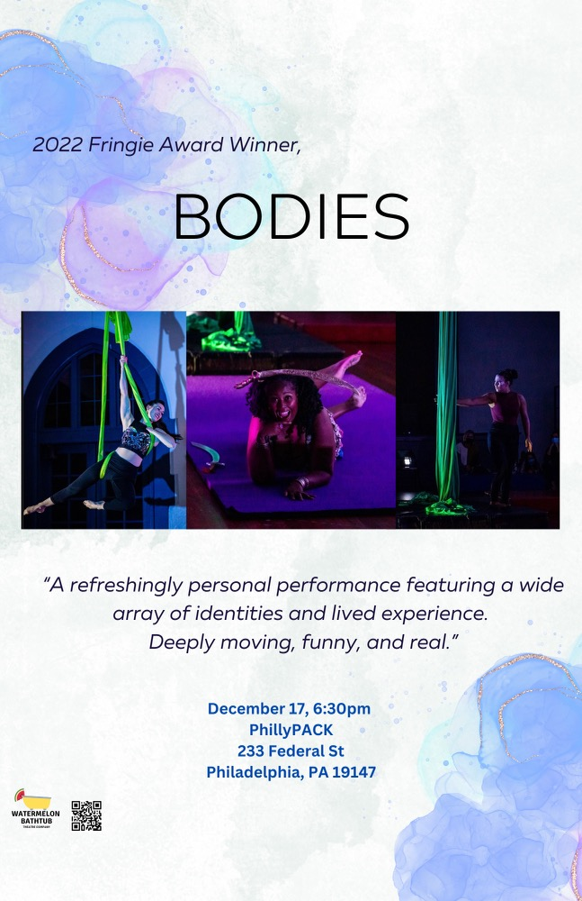

Bodies
a
Watermelon Bathtub

Production

Watermelon Bathtub is a Philadelphia-based theatre company.

Mission
To create impactful and accessible performing arts experiences with a commitment to showcasing artists and stories that are often untold.

About
Watermelon Bathtub Theater Company is based in Philadelphia and is made of Victoria Pirenoglu, Artistic Director, and co-founder and co-producers Melissa Mellon and Sarah Tuberty. Using spin off of their last names embodying the curiosity and redefinition of terms that their work creates.

This production is hosted by the Philly PACK
Philly PACK
233 Federal Street, Philadelphia, PA 19147

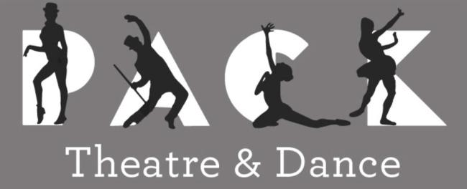
Figure 1 Philly PACK Logo

Please provide feedback of your experience following this QR code or this link
https://linktr.ee/watermelonbathtub

Access Notes:

Parking and arrival
- Street parking is ample in the neighborhood! please be mindful of parking in front of garage doors, and also in bus zone in front of PACK---PPA will ticket those zones.
- There are spaces near the building, but no accessible or van accessible designated spaces
- There is a ramp on the Moyamensing street side garage door
​
Entrance
- Wheelchair access through the Moyamensing Street side garage door
- The space has an entrance vestibule with one step down to access the mainspace room.
​
Bathrooms
- One gender neutral bathroom
- PACK restroom is not designated as ADA compliant
- One water fountain is present
​​
Seating and Performance Norms
- One gender neutral bathroom
- Folding chairs offered for guests, these can be moved around as needed
- Floor space will be available with mats
- PACK restroom is not designated as ADA compliant
- Fidget toys and sensory regulation tools are welcome
- Blankets, seat cushions, and pillows are welcome
- No strobe or flashing lights during performances
- Relaxed experience
- Touch tour offered 15 minutes before each show
- ASL Interpretation is planned (not yet secured)
- Transcript of audio elements will be available through digital program

Preshow Notes
This is a relaxed performance, movement, sound, and fidgets are all welcomed and encouraged.

There is an accessibility table with additional information and resources to help provide the pathways to access show content.

Seating surrounded the stage. The stage has 6 points where circus equipment is suspended from the ceiling.

The circus equipment we are using includes the following:

Lyra:
A large heavy metal hoop, suspended from the
ceiling. This hoop allows for a person to sit inside of it, and stand on top of it. There are span sets or, a type of rope, that connect the hoop to the ceiling. The hoop can spin around the point. The lyra is also called the aerial hoop.

Sling:
A sling is a large sheet of circus-grade fabric that is a vibrant color. This fabric makes a single very large loop, tying off at the attachment point. The fabric is soft, however, will become ridged when weight is put onto it. The sling can be used with all of the fabric bunched up together or spread out and a person can lay down in it like they are in a hammock. There is a swivel attachment that allows for the sling to spin. The sling is also called the aerial hammock, or aerial sling.

Fabric:
The fabric a large sheet of circus-grade fabric with two ends cascading down from the top of the rigging point. The fabrics are used by being wrapped around a body in various ties that someone unravels with the intention to allow for a drop. The fabric has an attachment that allows for the fabric to spin. Fabric is also called aerial fabric, tissues, aerial silks, or silks.

Set Up:
The stage is set facing the northwest side of the gym. Starting from right to left will be: a sling, a lyra, the stage pole, open center space, fabric, and sling.

Director: Victoria Pirenoglu

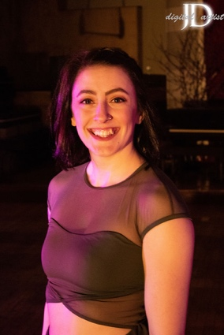
Victoria, (she/they) is a lover of movement from a young age and found circus at The Philadelphia Circus School of Arts in 2015. Building on a life-long foundation of hip hop and ballroom dancing, this discovery reignited her spark for expressing herself and telling stories through movement in the air.

Victoria is a full time circus coach at the Philadelphia School Circus School of Arts and performer. They have traveled up and down the east coast performing at places like The Muse, The Pool After Dark, and many others. She is excited to be working on this show and to give space to other performers!
Image 1 Headshot of Victoria, she is smiling at the camera›
“Bodie's is a show I have longed to see on the circus stage for as long as I have been in the circus. A show about people's experiences in their own bodies to different movement styles. Very often in the performing world we see the "beauty standard" that has been advertised to us on stage with little to no diversion in race, gender, body types and more.
Working with a diverse group of individuals to bring this exact show to the stage has been one of the most rewarding shows I have ever done. I hope this show moves you as much as it has moved me.”

CAST

Aneeta

Performer and Storyteller

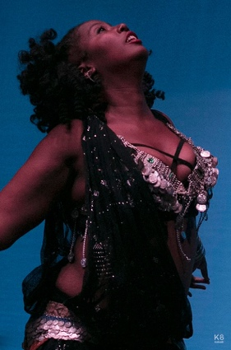
Aneeta (she/her) started bellydancing in 2001 with Najia and went onto study with June Seaney, Habiba, Kaeshi Chai, Oreet and Zoe Akili. She currently teaches at Mt Airy Performing Arts. She specializes in body positivity, teaching veil, cymbals and floor routine and assisting beginners in mastering the basics of the dance.

Image 2 Aneeta performing, she is dressed in belly dancing performance wear and her head is tossed up while engaged in movement

Em Holt

Performer and Storyteller

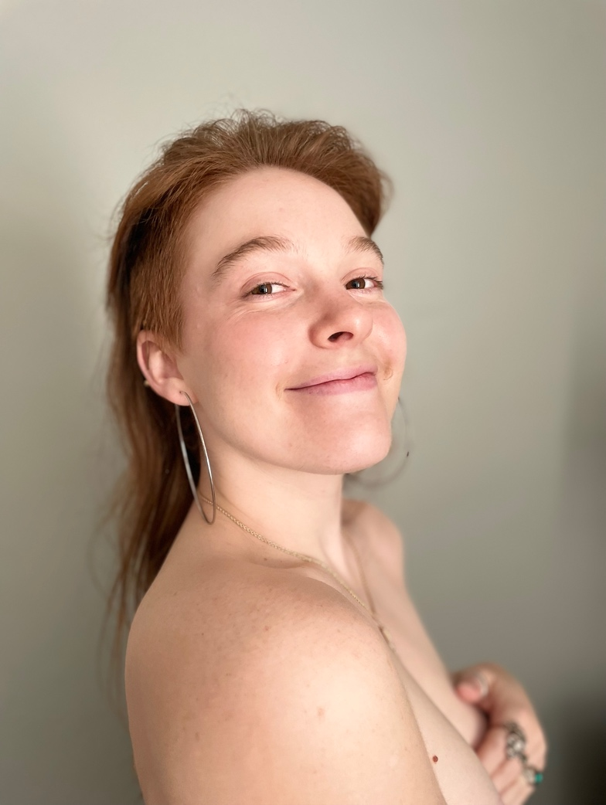
Em Holt (they/she) is a queer acrobat, burlesque dancer and visual storyteller based in Tallahassee, FL. After growing up in the competitive gymnastics world, Em swapped the gym for the tent while attending Florida State University. There, they balanced school and circus, studying Marketing and Documentary Film, but in truth, spending most of their time with the FSU Flying High Circus, specializing in swinging and flying trapeze. Having broadened their understanding of movement through belly dancing, swing, and hip hop, burlesque started as a pandemic project that became so much more. Through burlesque, Em found the perfect combination of movement, storytelling and entertainment. On stage, they showcase acts that blend ground acrobatics with dance and movement studies, assuming captivating personas within each. Movement is their compass, and with that, nothing is far out of reach.
Image 3 Headshot of Em Holt, they are smiling at the camera

Em is humbled to present an acrobatic dance piece exploring queerness, identity, and the body in this edition of Bodies.

Shanay Williams

Performer and Storyteller

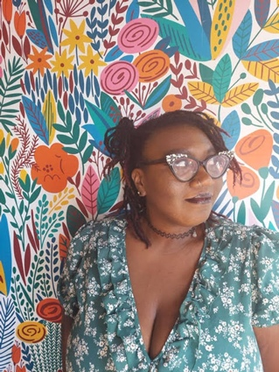
Shanay Williams (she/her)- you could say that community is in everything she does, by day she works in Public Health. Catch her in the afternoon? She will be coercing symphonic melodies from her cello; participating in local performances and charity events.

Never one to settle, Shanay then branched into a new hobby, aerials arts. What started as practice for movement has evolved into a performance expression that she is now ready to share with this community.
Image 4 Headshot of Shanay, she is looking off to her left and is wearing a floral shirt and is in front of a bright floral background

Rachel Lancaster

Performer and Storyteller

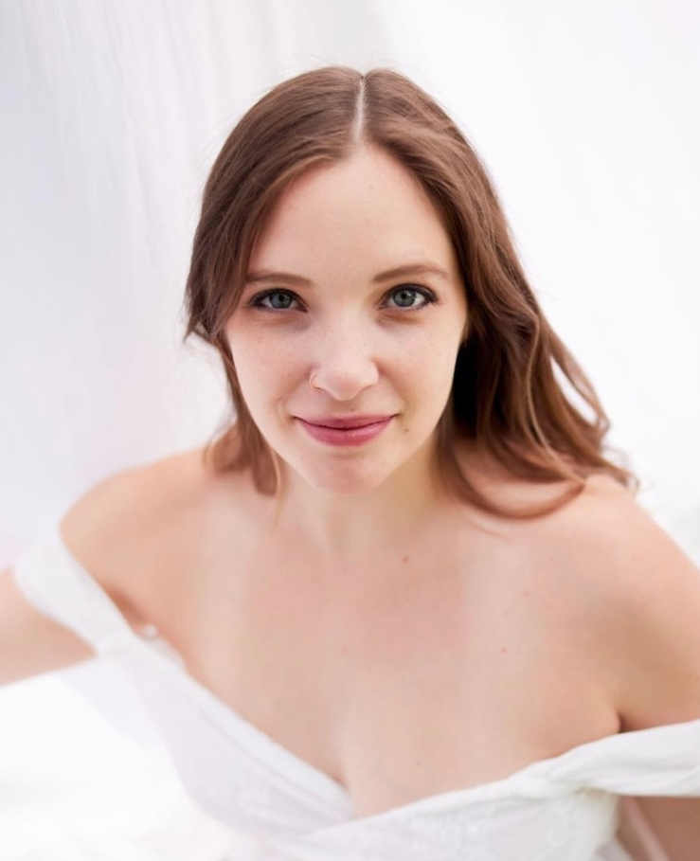
Rachel Mae Lancaster (She/her) is the head coach at the Philadelphia School of Circus Arts. She teaches a variety of classes for students of all ages and skill levels. Rachel has directed a number of showcases, staff shows, and youth performances at PSCA.
Image 5 Headshot of Rachel, she is looking right at the camera with a slight smile on her face

In addition to coaching, Rachel is a versatile performer who specializes in aerial acrobatics and circus arts. She began her dance career at the age of 3 and quickly discovered her love for performing. Through her journey in the dance world she found a passion for theater and decided that she wanted to learn more about acting and directing. She received a BFA at the University of the Arts in Philadelphia in theater arts.

After graduation, she continued to develop her talents while traveling and performing with a variety of different companies such as ToUch Performance Art, Innovative Juggler, and Airplay Entertrainment.

Amber Rambharose

Performer and Storyteller

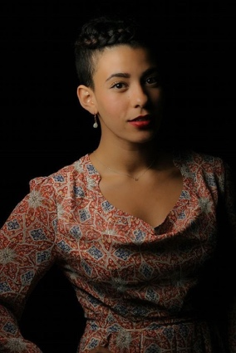
Amber Rambharose (she/her) is a Philadelphia-based writer and artist who has been studying aerial arts for three years and writing poetry for over a decade. Currently the beauty editor at Elite Daily, Amber spends her weeknights climbing silks at the Philadelphia School of Circus Arts and her weekends writing poetry and fiction. Her poetry and lyric essays appear in Linebreak, Rattle, PANK Magazine and Tupelo Quarterly, among others.

Her creative work, including the piece she is performing in the Watermelon Bathtub “Bodies” show, explores the relationship between self and body in the context of generational trauma and the strange alchemy that often occurs through the act of surviving.
Image 6 Headshot of Amber, she is looking at the camera with a slight smile

Melissa Mellon

Performer, Storyteller, and Co-Producer

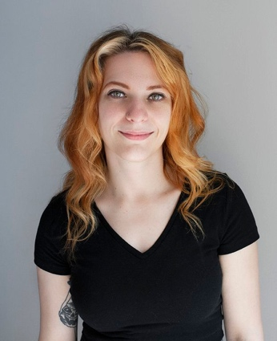
Melissa (she/her) studied Theatre Performance at Juniata College, where she trained in acting, movement expression, Skinner Releasing, Fitzmaurice Voicework, and was introduced to single point trapeze. She finally made her way to training at the Philadelphia School of Circus Arts where she is now a youth and adult coach.

Melissa is skilled in aerial arts on the lyra, trapeze (single and double point), pole, lollipop, and sling. She is also trained in fire flow and safety. She is available for aerial bartending, as well. Her favorite thing to do is create beautiful flying and ambient acts.
Image 7 Headshot of Melissa she is looking at the camera and smiles confidently

Sarah Tuberty

Performer, Storyteller, and Co-Producer

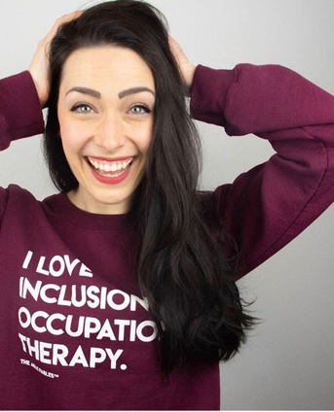
Sarah Tuberty (she/her) studied Occupational Therapy at Boston University, and is in a PhD in Occupational Therapy program at Texas Woman's University.

Sarah has studied and trained in accessible aerial arts, and has a particular interest in the psychosocial impacts of disability and disability identity. Especially in spaces where the disability narrative is so often told from individuals outside of the disability community. Her work is to showcase stories and perspective of the authentic disability narrative.
Image 8 Headshot of Sarah, she is smiling wide, looking at the camera and has her hands on her head

Sarah has trained internationally in the lyra, fabrics, pole, and trapeze.

Bodies Partners

ASL Interpretation: ASL Services

Annie Hardway is a certified (NIC-Master, NAD-IV, AOPC) interpreter. She started learning American Sign Language at the Rochester School for the Deaf, was privately mentored in interpreting, and worked in a mentorship program and as a staff interpreter at the National Technical Institute for the Deaf in Rochester, NY. She has been providing interpreting services throughout South Central Pennsylvania for over 25 years.
Image 9 ASL Services Logo

Website: Aslservicespa.com

Photography: Ashley Smith, Wide Eyed Studios

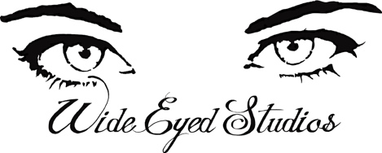
Ashley Smith (she/they) started Wide Eyed Studios 10 years ago with a desire to document the beauty of humans with heart, humor, honesty and a lot of dynamic color.
Image 10 Wide Eyed Studios Logo

With a background in Visual Anthropology, Gender Studios and Photojournalism, she loves using her skills to illuminate theater, dance, music, love, families, schools and nonprofits.

Website: wideeyedstudios.com

The following is a collection of access elements, the transcripts of the audio and a general written description of movement in show order.

Aneeta

The Body I Inhabit
Narrative  Description:  Aneeta is an African-American plus-sized bellydancer. Her act will include slightly improvised sword balancing with a focus on body positivity.  Content Considerations: Her act will include slightly improvised sword balancing with a focus on body positivity.  Song: Ou Est Ma Petite Danseuse (Where Is My Little Dancer) by Gypsy Caravan.  Spoken word: Aneeta recorded her own voice.  Begin:  Although there are many plus sized belly dancers, I always have a moment of panic as a woman of color outside the ideal size before I perform. Will I fit into the audience's idea of a belly dancer? Will they be disappointed if I am not thin enough or my skin is too dark and demand a refund? When I was 29, and in an upper state parade, a group of teenage girls surrounded a plus sized troupe member and refused to believe she was a dancer.  Although I love serving as an example to my students that belly dancers come in all sizes and all colors, I can't stop comparing myself to size zero professional dancers and their ability to maintain that weight as the pounds pile upon mine. Sometimes before teaching, I typically layer 2-3 tops for maximum support. When I initially grew in size, I wore a belly cover - either a chain or see through girdle or full body gahwazee dance coat to hide the weight. After failing to find a costume at a bellydance festival with plus size sellers, I gave in and commissioned a new one. The costumer complained about making a costume that large after payment.  One of my incredibly thin students told me she couldn't perform because she didn't have the body of a bellydancer. I asked if she had ever seen any professional belly dancers. She said no. I asked if she felt anyone in the room, including myself and the other instructor, fit that body stereotype. She said no. Even after I listed numerous plus sized dancers, she still insisted, that she herself did not have that body and could not perform.  Sometimes people commit offense without meaning to. While teaching for a library workshop, the coordinator swapped out my PR shots for that of a thinner Caucasian dancer. Every now and again fellow dancers or students will emphasize their thinner weight compared to mine. When teaching in Mt Airy, an older Caucasian student could not believe I was the instructor despite my choli, boombox and headless mic.  So this is why I continue. Even though I'm no longer 20, no longer 130 pounds, do not wear long, straight hair and have never had light or white skin. At every venue I perform, for those outside the dance community, I introduce a new concept, a real concept. Not one grounded in 1950s films and cis het white male ideality but in reality and in the skin, the color, the form, and the body I currently inhabit. | Movement description  Begin:  Aneeta attempts to balance the sword on her head while shimmying.  Aneeta executes a series of turns, undulations and figure 8s.  Aneeta sinks to the ground to her knees and executes kneeling undulations within a circle while balancing the sword on her head.  Aneeta will attempt to do a reverse plank on the ground with stomach undulations while still balancing the sword on her head.  Aneeta will possibly add a second sword and balance on her chest.  Aneeta will either raise to her feet with both swords and end in a pose or remain on the ground and pose with both swords.

Amber Rambharose

Love Your Difficult Self
Narrative  Amber: Amber identifies as a biracial woman. She has brown skin and long, curly brown hair. Amber performs on the fabrics.  Content considerations: Discussion of trauma and body harm through seasonal metaphors.  Song:  Spoken word: Amber recorded her own voice  Begin:  I've lived here longer than three decades, but I am still a stranger in my body.  I still need a map to find sleep  An alarm on my phone to ring  hungry because I never quite learned how to eat or meet my own needs.  And I often give up in the middle.  My body has learned, I only give it what I think I deserve and that's very little.  This body of mine  I have salted it's soil because sometimes what it does makes me feel so strong and special and then other times  it leaves me undone.  Every time, my heart races and my mind can't keep up every fight or flight frenzy when I'm flinching or freezing.  Every time I start crying when I want to stay calm.  Every time any calmness eludes me.  Then I hate it here  And I want to go home  To a better one.  Less prone to bruising  a home with an alarm system that's actually working.  A home full if dopamine and serotonin  Where every emotion doesn't cause a flood in my brain that I drown in.  This happens so often that there are water marks and salt stains on the backs of my eyelids.  This body is always exhausted.  Always vigilant and fearful.  Every compass here points to survival and I couldn't find happy if you took my hand and showed me the path.  This body would orbit me right back to being terrified, waiting for the tide to wash in some threat unidentified but harmful.  It gets so lonely on this storm-born Island that sometimes I forget the way it started.  This topography of jagged pain responses, my body has never forgotten.  It remembers things that only come to me in dreams I wake up from with blood in my mouth because I've clenched my teeth so hard they cut my cheeks.  My body won't give back those memories.  And forgives me the taste of pennies in the morning.  It forgives me for, at 17 falling in love with my rib cage, without warning spending the next 10 years of starving, Until I became just water with a bedsheet thrown over a surface for my bones to float up to and press against it  And again, my body for gave me the dangerous men  for believing neglect was the bed I slept best in.  For trying to breathe through my skin.  My body forgives it's constant excavation  for the fires I set inside of myself for burning every Garden down.  Because I never believed I was worthy of roses.  I am.  And my body knows this.  And I still can't quite forgive it.  But I am trying to forgive my body. It's surviving for every time I've given up and my lungs just kept on breathing.  Each time I tell myself, I'm nothing my body tries to show me “Look”  After a forest fire nutrients from dead trees feed their seedlings siblings  And there is a plant in the spike Moss family that can survive for years without a drop of rain.  Soil is more fertile after being struck by lightning.  It takes a star of a billion years to die.  And even after, it keeps shining.  And if M-Theory is to be believed and pressed close to this galaxy is another one, where the Earth we live on isn't dying.  When I can't fall asleep  When I'm too sad to eat  When I am floating body whispers somewhere.  it's still snows and it is snowing and there are crocuses unfurling.  Somewhere there is a you that wasn't called so early.  A you that grew up smiling somewhere.  This body is glowing and that possibility means something  it's still could happen here.  Watch close  right  now.  It's happening. | Movement description  Begin:  Amber approaches the fabric and it is split, she reaches each hand up the fabric individually and looks around  She climbs  She folds over into a hip key and wraps her bottom leg and begins to spin.  Amber spins  Amber spins and brings her body upright and through the fabrics into a back balance.  Her legs change position as she reaches above her head to the fabrics wrapped by her feet  She transitions into a gazelle shape  Amber moves her arms and legs  Amber reaches for the fabrics behind her and waves them, her knee is the highest point suspended in the fabrics as her body and legs arch in an inverted back bend below her knee.  Amber climbs up over her legs, and rotates into the front of the fabric  She lets go of the fabric behind her and dives forward into a 360* dive drop  She holds on to the fabric above her head and waves her legs to unwrap the fabrics  She splits the fabric and wraps her legs at the same time in the air, above fabric on each leg.  She bends forward  Amber wraps the fabric around her feet  She brings her legs up behind her into a ½ monte drop, her knees bend and her body tips forward with her head to the ground  She moves the fabric to spin  Amber is, into an inverted backbend, her feet nearly touching her head as she spins.  She climbs up above her knees, unwraps her legs and descends

Em Holt

Not a Man, Not a Woman, a Third More Secret Thing
Narrative  Descriptions:  Em: Em is a small, white, genderfluid person. The sides of their head are shaved and the rest of their long red hair is gathered in a loose bun. They are shirtless with black “X”s over their nipples. They're performing an acrobatic dance routine.  Content considerations: The piece mentions bullying and harassment due to body hair.  Sound: A melody composed of Please be Naked, An Encounter, and 12 by The 1975.  Begin:  It’s beautiful when people feel free and safe enough to be themselves.  I stopped shaving my body hair for a couple of reasons.  I stopped because legs are long and it’s a lot of work. I stopped because I had such a nasty ingrown hair in my armpit, that when I plucked it, it left a hole big enough to thread an earring through. Picture that, right? Gross. But the most profound and unexpected reason was because the moment I saw blonde whiskers in the mirror, I saw this gorgeous man looking back at me for the first time.  My body hair is sacred to me because it helps connect me to all the versions of myself, and all the energies that I hold within myself. It’s like my key to unlocking all the delicious, genderful secrets of humanity. My body hair makes me feel euphoric and divine. And it helps me feel like myself, always.  When people ask me about sexuality and identity, I tell them, “I’m queer.” But for me, queer is more than just a label. It’s a way of existing.  As bell hooks writes, “‘Queer' not as being about who you're having sex with… but 'queer' as being about the self that is at odds with everything around it and that has to invent and create and find a place to speak and to thrive and to live.” To me, “queer” is all encompassing, it’s how you move through the world. And I think queer is understanding that the only right way to exist is how you are most yourself.  While embracing my body hair truly has brought me so much joy, some people have made it their business to tell me how gross I am. The occasional nasty comment or unsolicited DM still gets to me. I’ve lost spaces and people I used to feel safe with because I couldn’t pass anymore. Not to mention, it can be scary going out into the world with an outward expression of queerness because what if the wrong, hateful, dangerous person sees me. This is such an exhausting reality, and sometimes I do hide.  But then I think, what if the right person is watching. I wear my body hair for myself, but I wear it for those people, too. The people who matter. You deserve to exist how you see fit. And we will continue to carve out spaces to speak and to thrive and to live. | Movement description  Begin:  Em stands center stage. Their arms move, then their shoulders, then torso and legs as 4 piano sequences seem to wake up their body.  Em traces one arm with their hand, touching their face, then drops their arms to their sides.  They perform a tumbling sequence, moving forward to the front of the stage.  They smile and move their legs in a funky fashion.  Em raises their arms, highlighting their body hair then does a butterfly kick, landing with their back towards the audience.  They turn and walk slowly backward, touching their face, reaching forward, looking relieved and emotional.  Em rolls to the floor and sits on both knees. They peer at the ground, tracing it like a pool of water. They pretend to scoop the water and whirl their arms in circles around their head.  Em lifts themselves into a lunge, sits back onto both knees, and rolls forward into a chest stand, spins and rolls down to their knees on the opposite side.  They stand and improvise what joy feels like in this moment.  Standing center stage, they sigh, look resolved and gaze at the audience. They crouch to the ground, spin, and move their legs in a windmill over their head and roll to standing.  Em paces around the stage perimeter, accentuating some of the words with big steps, leaps, flips, and grand arm gestures.  Em reaches the back, center stage and begins to walk towards the audience in slow motion.  They pretend like they are being hit on the arm, then the leg, falling slowly to the ground.  Em struggles to get up and their knees buckle under them. They sit on their heels, put the back of their head on the ground, letting their arms sprawl to the sides.  They roll and lay flat, then sit up with their back to the audience.  Em presses into a handstand and rolls into a lunge. They flip, stomp and spin with the rhythm of the music, improvising what power feels like in this moment. Em comes back to their starting pose in center stage, this time with their arms raised over their head.

Shanay Williams

My Body Takes Up Space
Narrative  Description: Shanay identifies as a black plus size femme with large black and diamond cat eye glasses with purple and black hair. She will be performing on the aerial sling. She will be wearing a purple lace body suit with black tights.  Content Considerations: Piece discusses body image and reflections.  Song: Lunar Rhapsody, Dr. Samuel Hoffman & Les Baxter.  Spoken word: Shanay recorded her own voice.  Begin:  My Body  My Body is curve  My Body  My Body is mine  My Body is strong, and it supports me  It holds me  My Body is Strength  This Strength that carries me through every day  Its Grace  I should give my body the grace it deserves  And take up space  I will not shy away  I will show my strength and grace  I will be proud of my curves  And appreciate what my body does for me  While I’m in the air  I will show what body can do  I will show the world the strength t the body has  And not be ashamed. | Movement description  Begin:  Shanay lays on the ground on her back,  She moves her arms in a flowy motion while laying on the ground  Shanay now rolls into a shoulder stand and hold her lower back with her hands. She waves her legs in the air  Shanay rolls back to the ground her hand follows her leg to her foot  Shanay now stands up and looks at the sling  Shanay puts the sling being her and begins to swing  She then puts one leg up and spins faster  She then grabs up high on the sling and pulls herself up  Shanay then moves her leg through the sling, and is now in upside down stag. She then hooks her leg on the sling and sits in upright position.  Shanay then lower herself by rolling through the sling. And making a crescent shape in the air.  Shanay’s feet touch the ground, and she leans back her in sling.  Shanay then begins to spin in her sling with the sling under her arms and inverts into a gazelle shape  She ends the performance spinning in her sling

Rachel Lancaster

Newborn
Narrative  Descriptions:  Rachel: An exhausted white woman with messy brown hair wearing a nude outfit giving the appearance of being naked  Content considerations: Includes themes of Pregnancy, childbirth, and Postpartum depression  Sound: Song Fix You - Instrumental Version by Immanuel Michaels  Begin:  *Note there is not spoken word for this piece.  White noise fades to silence, Song Fix You - Instrumental Version by Immanuel Michaels, a baby cooing | Movement description  Begin:  Woman sits rocking her newborn baby. She appears to be sleeping.  Suddenly she wakes in a panic, looking around for her child. She realizes that her baby is asleep in her arms.  Slowly she raises to place her baby in the crib. She kisses her hand and gently touches it to her baby's head before she creeps away so as to not wake the baby.  She collapses from exhaustion.  She attempts to gather the strength to pick herself back up again. She covers her belly and turns to walk away.  She approaches a maroon fabric and unties a knot.  She glaces once more over to the crib to make sure her baby is still asleep before turning herself upside down.  She pulls herself slowly up the fabric.  She wraps herself in tangles, expanding and contacting, at moments hanging from nothing but her hands.  She curls herself into a ball clutching her newly empty belly.  She twirls the end of the fabric to spin herself around. Once spinning she opens her heart to the sky.  She threads her body through and around the fabric pushing and pulling on her body. She starts to descend, flipping and rotating as she goes.  Once she reaches the floor, she walks forward and holds her hand over her heart. Her baby makes a noise, she looks over and smiles.
Notes:
Becoming a new mother involves a lot of nuanced and complicated emotions. Rachel's piece confronts the struggles that she faced during her recovery after an unplanned C-section, and the overwhelming and isolating feelings of postpartum depression. This piece is about fighting her way back to owning and loving her body again, all while embracing her new role as a Mama.

Melissa Mellon

Flares
Narrative  Description:  Melissa, a white woman with red curly hair, who stands about 5’3” and is of a slim frame. She performs on the lyra.  Content considerations: Discussion of marijuana use.  Song: Granular Haze by Chihei Hatakeyama.  Spoken word: Melissa recorded her own voice.  Begin:  Flares have always eluded me. I can’t figure out the momentum, the shift in weight, the driving leg - does it switch - is it opposite? I’ve been told that I will feel it, and I’ll know if it’s right or wrong. But both feel equally wrong, and equally potentially correct, and maybe just poorly executed. It wouldn’t be the first time that my body has felt indescribable.  The first time that it happened - a flare up - I thought that I was losing my mind. I was physically exhausted. No amount of sleep or caffeine could wake me. I went into a coffee shop and saw a drink on their menu that had 5 shots of espresso in it. I looked at the menu, barely comprehending anything else, and I said “That one!” I promptly fell asleep. At work.  And everything hurt. I mean everything. The wind blew my hair and I burst into tears. Gripping my steering wheel was physically impossible. I was also incredibly confused and lost in a brain fog. I would stare off and not be able to register anything that was going on around me. This cage of disorientation, exhaustion, and pain lasted for 5 days.  Then, like a light switch, I was fine. I had the energy of a puppy! And with this tumultuous week behind me, I felt crazier than ever. That is, until it happened again. And again. And again. Each time, a month or two in between, but always lasting 5 days.  When it happened again, I was lying in bed, and I was so cold. Being unable to regulate my body temperature is also a super fun symptom! I was shivering, and sobbing because I was freezing, but the weight of my blankets was too much for my body to bear. So with nothing else to do, I went to my kitchen and opened my fridge. Because that’s what we all do, right? I don’t know what to do so I’ll just open the fridge and hopefully the answer will be there. Makes sense. Never works, but we all do it.  My roommate at the time caught me and my tear-streaked face. We chatted and he casually offered, “Do you want a pot cookie?” “Yes! Yes, I do! Anything!” And finally, it happened - relief! My flare up lasted a record three days with tapering symptoms after getting high! Yes, this is it! This is what I’ve been looking for! Funny story - not every doctor believes in fibromyalgia. The ones in the area that do, aren’t the ones with a medical card hookup. I bought some pot and then hoarded it. And I’m still hoarding it. I’m saving it for a flare up. But when it happens, I think, “well, what if this one isn’t as bad as the next one? Like, there could be a really really bad one coming, and I don’t wanna be out of my stash.” So then I suffer. And then when the next one hits, I think the same thing. I hoard my pot and I’m terrified to use it because what if I use it and then suddenly I really need it?! It’s not a great system.  Now, my body can do some pretty amazing things, arguably. But there are some days when I can’t even get my sports bra on. “Hunny! Hunny! Help me!!!!” My partner runs in from the other room thinking I’m dying. And we both can’t help but laugh as he saves me from my spandex cage and rides off into the sunset.  My body has given me the amazing opportunity to coach and to perform professionally. When I was diagnosed and told my doctor that I do “circus” for a living, I thought they would tell me to stop. But she told me something that works to ease symptoms is moving your body every single day.  Flare ups can still be brought on by stress. For instance, do you folx know when a performer might get really stressed out? Before a performance of course! I find myself bartering with my body. If you can make it til after this show, I will willingly accept my flare up. And I tell myself that it will be fine - a much needed rest where I can do nothing but get sooooo high. (Shakes head no)  In the last year, I quit my job that I hated and that caused me so much depression and stress that I was having flare up after flare up (not to mention a boss that also didn’t believe my diagnosis. “But you don’t look sick”). And now I’m doing even more circus than I was doing previously in a warm and inclusive environment. My flare ups are now few and far between. My flares on the other hand - meh, I should just give it a rest. | Movement Description  Begin:  Melissa hangs from the top of the Lyra, attempting to do flares. She can kick to each side 2x.  She spins the Lyra and mounts from the side, hanging from one knee and climbing up.  As the Lyra spins faster, she does a front roll and is back to the top before landing in a cuddle position.  She grabs the hoop at the top and bottom and let’s her body hang before hooking her knee and dropping to a single knee hang.  She wraps herself at the bottom of the hoop with her knees and elbows like a sloth.  She climbs to the center of the hoop, and does a backward split leg roll, and sets up for another, but lands in a single hip hang.  She extends her legs up into the hoop and locks the opposite sides, hanging by her feet.  She climbs to the center, and slides back to her knees, taking one leg over the other and flipping the hoop around her. She straddles out and wraps her legs around the hoop. She then slides her body through the hoop, still gripping with her legs.  She climbs through the center and drops off to the side of the Lyra, legs moving beneath her.  She returns to her cuddle position and rolls off of the front of the Lyra. Climbing back through the center, she wraps her hands in the fabric tethers and stretches her body forward. She then does the opposite, bringing her back and down, stretching her feet to the hoop. She begins to pick up speed as the story continues it’s back and forth escalation.  She lands in a perch in the center of the hoop, and then inverts to the top of the Lyra. She grabs the top and bottom, and let’s her body go. She remains inverted, holding on with only her top hand.  She climbs to the top of the hoop, and then slides down through the tethers. She is stuck between them, flailing to get free. As she is freed, she slides down the front of the hoop. She keeps her wrists wrapped as she brings her body up and over the top of the hoop into a hip hang.  She rolls over the lyra, into a twisted arm hold. From here, she wraps her legs around the tethers, and extends the hoop behind her. She then switches her legs, landing in a single knee hold on the tether. This hold allows the hoop to swing around, and she braces the opposite does with her foot and balances.  She executes a shoulder dismount from the hoop. As she reaches for the top of the hoop, her body hangs below, and her right foot starts to generate a spin.  From this spin, she winds up, fan kicks across her body and pulls into the hoop - finally getting her flare.

Thank you for coming!!!

Visit our linktree!
https://linktr.ee/watermelonbathtub

Here you can:

Submit a review and feedback
Get Merch
Donate for future shows

Huge thank you to our sponsors
and
everyone who has supported the show

