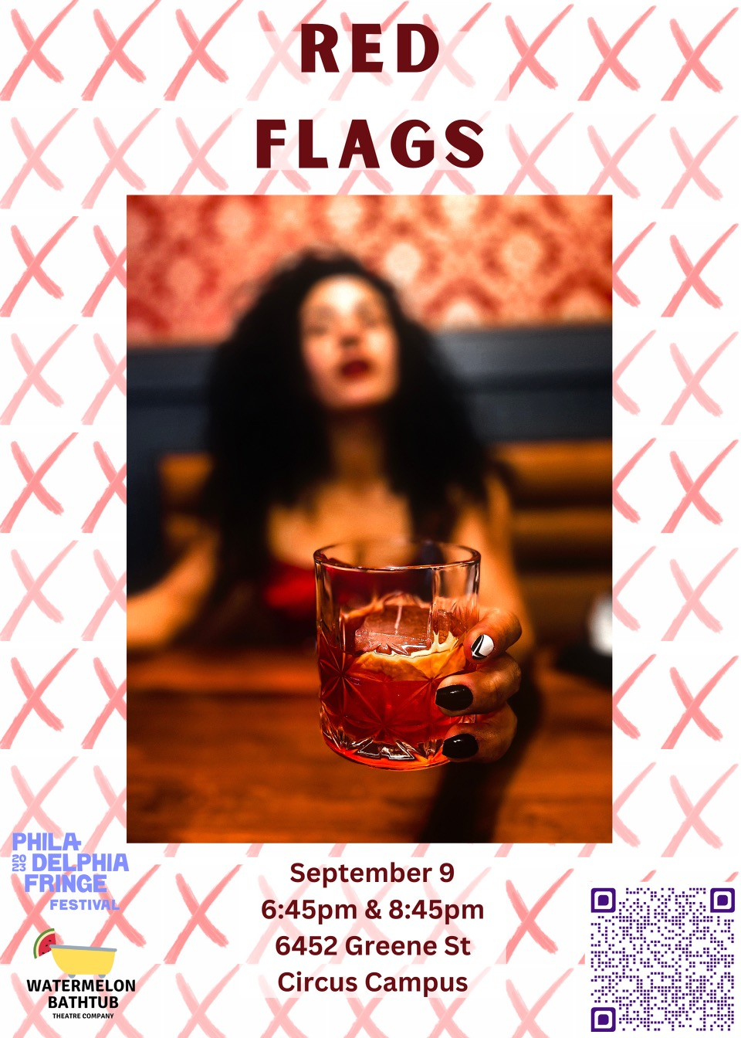

Red Flags
a

Watermelon Bathtub

Production

Watermelon Bathtub is a Philadelphia-based theatre company.

Mission
To create impactful and accessible performing arts experiences with a commitment to showcasing artists and stories that are often untold.

About
Watermelon Bathtub Theater Company is based in Philadelphia and was created by two circus artists, Melissa Mellon and Sarah Tuberty. Using spin off of their last names embodying the curiosity and redefinition of terms that their work creates.
This production is hosted by the Circus Campus Hub
A part of the Philadelphia Fringe Arts Festival

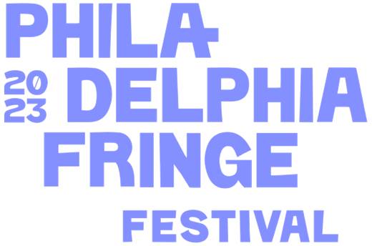

Image 1Fringe Arts 2023 Festival Logo

Access Notes:

Arrival
- Circus Campus Presents is accessible via car and public transportation
- Upsal stop on the Chestnut Hill West Line
- Walnut ln & Green street on 65 Germantown-Chelten Bus Line
- Limited Parking in back parking lot along Cliveden street behind the circus school
- Accessible Parking
- Street parking along Cliveden, Greene and surrounding streets available no payment necessary

Entering the building
- This years performance is in the Sanctuary, which is wheelchair accessible
- If entering from the back parking lot, there is a sidewalk leading up to the side entrance of the building.
- If entering from Greene street there is a flight of stairs leading up to the east side of the building
- There will be a light on an Fringe sign
- Signs will direct all patrons to an accessible entrance on the east side of the building
- Tickets will be sold at the door

Restrooms
- 4 gender neutral single stall restrooms on main floor
- 2 restrooms are wide to accommodate a wheelchair turning around, however do not have grab bars
​

Performance
- ASL interpreters for both shows
- 4 acts in total, each act has the spoken word transcript and movement description in digital program
- Content considerations include
  - Discussion of toxic relationships
  - Discussion of body trauma

Access
- Accessibility table and accessibility lead will have resources to support access and sensory regulation for show
- All of the following are welcome to help support engagement in the show as needed
  - Service animals
  - Ear plugs
  - Sunglasses
  - Weighted materials
  - refillable water bottles
- Seating provided are metal folding chairs. Blankets, cushions, and pillows are welcome
- Matts are available for seating
- Relaxed performance includes:
  - No strobe lighting
  - No extreme lighting (it will not be very dark or very bright, lighting will not change erratically)
  - Movement throughout the show is welcomed and encouraged

Please provide feedback of your experience following this QR code or this link
https://linktr.ee/watermelonbathtub

Preshow Notes
This is a relaxed performance, movement, sound, and fidgets are all welcomed and encouraged.

There is an accessibility table with additional information and resources to help provide the pathways to access show content.

The bathrooms are located in the main hallway. Water station, donuts, and coffee are located in the foyer.

The circus equipment used includes the following:

Lyra:
The lyra is a large heavy metal hoop, suspended from the ceiling. This hoop allows for a person to sit inside of it, and stand on top of it. There are span sets or, a type of rope, that connect the hoop to the ceiling. The hoop can spin around the point. The lyra is also called the aerial hoop.

Fabric:
The fabric a large sheet of circus-grade fabric with two ends cascading down from the top of the rigging point. The fabrics are used by being wrapped around a body in various ties that someone unravels with the intention to allow for a drop. The fabric has an attachment that allows for the fabric to spin. Fabric is also called aerial fabric, tissues, aerial silks, or silks.

Wire:
The wire is thick cable that is about 12 feet in length, about 2.5 feet in height and spans the width of the stage. There are two pedestals on either ends that a person can stand on.

Hula Hoop:
The hula hoop is a large plastic hoop.

Stage Set up:
Seating surrounded the stage. The stage has 2 rigging points, with the fabric located on the left half of the stage and the lyra located on the right side of the stage. The fabric and lyra are swaged back to the sides while they are not in use.

CAST and Crew

Amber Rambharose

Storyteller and Performer
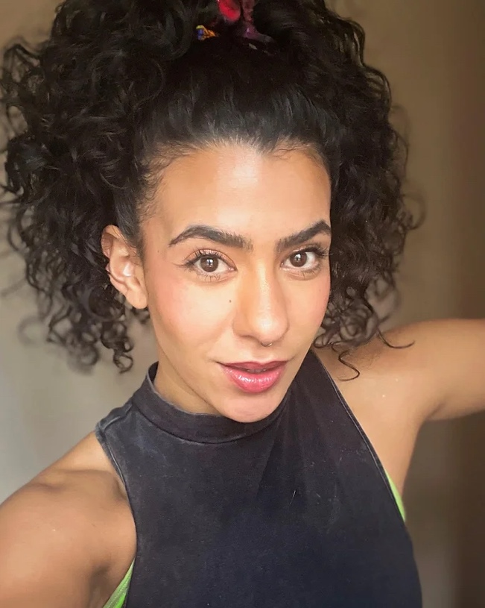
Amber Rambharose, She/Her, fell head over heels in love with aerial arts in 2018 and hasn’t looked back since. She has performed for Alterra Productions, Tangle Movement Arts, and Watermelon Bathtub’s award-winning “Bodies” show.

When she’s not spinning upside down on a Lyra or untangling herself from aerial silks, Amber coaches students of all ages at the Philadelphia School of Circus Arts. Yes, she also has a day job. A writer and editor with over a decade of experience, Amber’s byline can be found in InStyle, Allure, Glamour, Bustle, Marie Claire, and Cosmopolitan magazines where she writers about fashion, beauty, and culture, with an emphasis on marginalized voices.
Image 2 Head shot of Amber
Amber is looking at the camera. She is wearing a black sleeveless top and has her curly hair tied up, leaving the curls to flow around her.

Her creative writing has received awards from the Academy of American Poets, the Pushcart Prize, and the Lex Allen Literary Festival, and has been published in Rattle Magazine, the Adroit Journal, and Tupelo Quarterly, among others. She is a very online millennial

Victoria Pirenoglu

Storyteller and Performer

Artistic Director

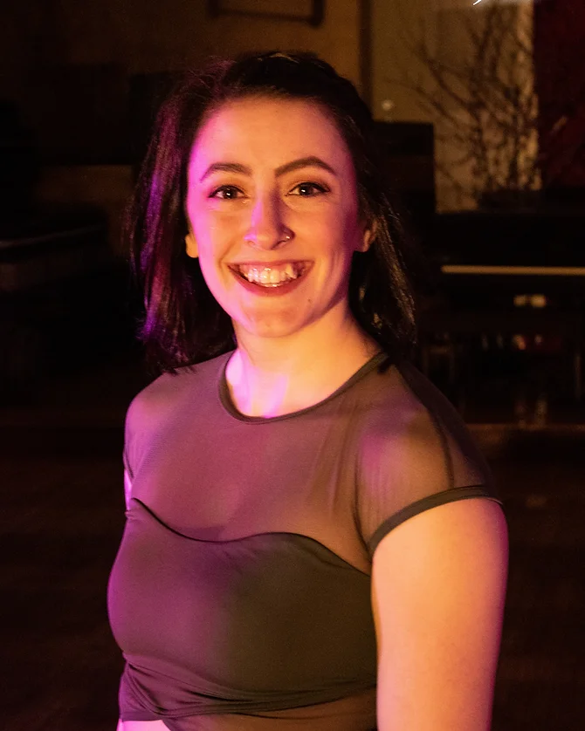
A lover of movement from a young age, Victoria, She/Them, found circus at The Philadelphia Circus School of Arts in 2015. Building on a life-long foundation of hip hop and ballroom dancing, this discovery reignited her spark for expressing herself and telling stories through movement in the air. Victoria is a circus coach at the Philadelphia School Circus School of Arts and performer.

They have traveled up and down the east coast performing at places like The Muse, The Pool After Dark, and many others. She is excited to be working on this show and to give space to other performers! ​ She is fabulously entertaining with aerial acts such as: aerial fabric, lollipop Lyra, sling teardrop trapeze and many other apparatuses. - fantastic ambiance services, roving, fire performances and more!
Image 3- Head shot of Victoria
Victoria is looking at the camera and smiling

Bethany McPerson

Storyteller and Performer

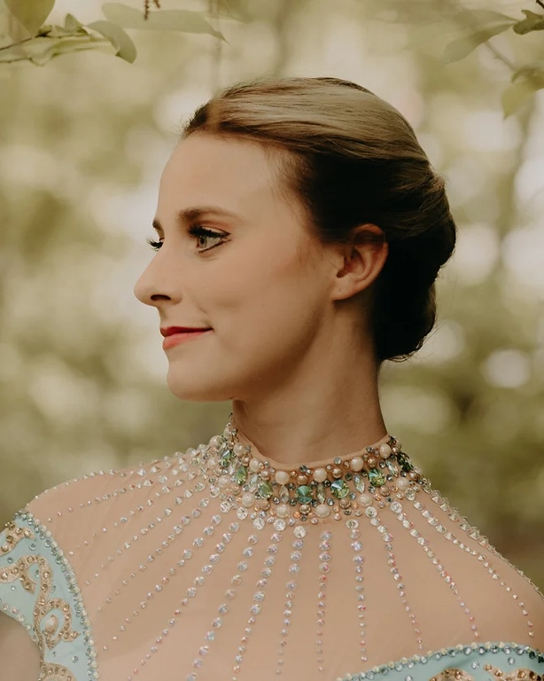
Bethany, She/Her, attended two years of NECCA’s ProTrack program with a major in Tightwire and a minor in Acrobatic Dance.

She’s performed with Bindlestiff Family Cirkus and Time Flies Circus.

Bethany also has a B.S. in Sport and Exercise Psychology from West Virginia University, with a minor in Family and Youth Studies. Outside of circus, Bethany enjoys reading, knitting, running, and relaxing with her dog Sophie.

Image 4 Headshot of Bethany. The pictures shows a young woman looking to the left with blonde hair pulled back. She is wearing a teal dress with gold accents and a rhinestone neckline.

Melissa Mellon

Storyteller and Performer

Co-Founder and Producer

Melissa, She/Her, studied Theatre Performance at Juniata College, where she trained in acting, movement expression, Skinner Releasing, Fitzmaurice Voicework, and was introduced to single point trapeze.
Image 5 Head shot of Melissa, A white woman with red curly hair and a gold colored top, smiling at the camera

She finally made her way to training at the Philadelphia School of Circus Arts where she is now a youth and adult coach.

Melissa was a cast member in the first two Watermelon Bathtub showings of “Bodies” and is so thrilled to have the opportunity to continue to tell her stories.

Kiki Le Boudoir

Storyteller and Performer

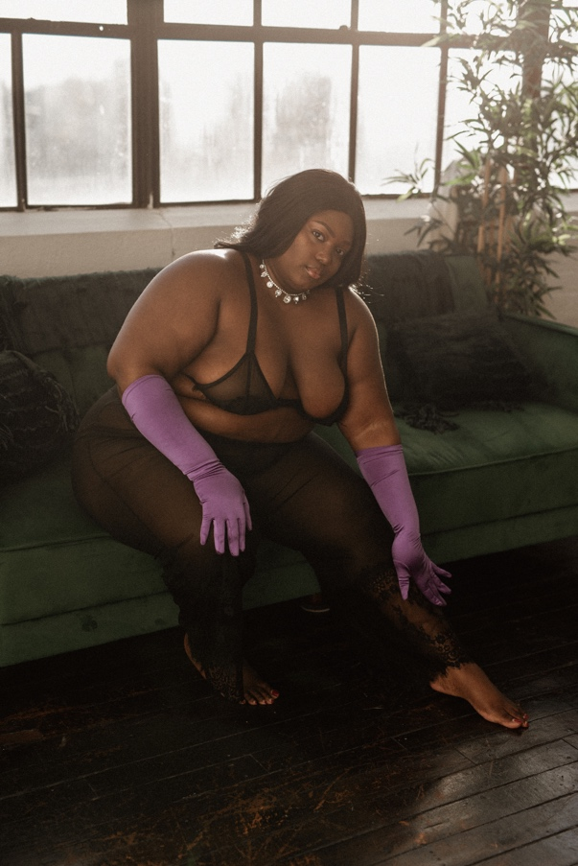
Kiki Le Boudoir (She/her) is a graduate of the Philadelphia Burlesque Academy and has performed in countless shows throughout Philadelphia. She teaches pole fitness at Awakenings Pole Fitness where she teaches the art of sensual movement to plus size athletes. She is also the CEO of Curvy and Seductive, a plus size lingerie brand that encourages full-figured women to own their sensuality.

Tagline: "Meet her in her boudoir, where slow and sensual wins the race."

Image 6 Kiki is dressed in boudoir and is leaning sensually over - reaching down towards her legs

Kate Hanley

Stage Manager

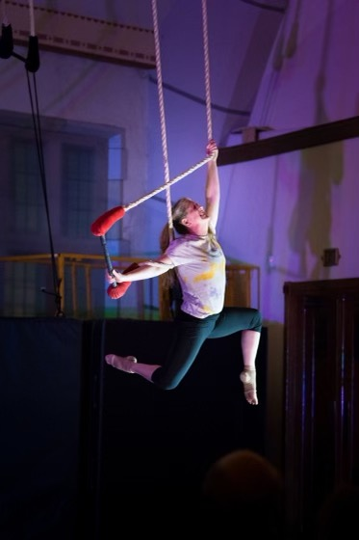
Kate is a professional theater artist who has worked with the Arden, People's LIght and Theatre Company and Circadium School of Contemporary Circus.

She caught the circus bug when her daughter started taking classes years ago (it was either take an aerial class or go to a bar, she chose wisely).

She currently teaches classes in circus and stage management at Arcadia University where she also serves as the Administrative Director for the Office of the Provost.

Image 8 performer photo of Kate suspended in the trapeze, knees bent in a gazelle pose

Sarah Tuberty

Accessibility Coordinator and Co-Founder

Sarah Tuberty (she/her) studied Occupational Therapy at Boston University, and is in a PhD in Occupational Therapy program at Texas Woman's University.

Sarah has studied and trained in accessible aerial arts, and has a particular interest in the psychosocial impacts of disability and disability identity. Especially in spaces where the disability narrative is so often told from individuals outside of the disability community. Her work is to showcase stories and perspective of the authentic disability narrative.
Image 7 Headshot of Sarah, she is smiling wide, looking at the camera and has her hands on her head
Sarah has trained internationally in the lyra, fabrics, pole, and trapeze.

Bodies Partners

ASL Interpretation: PRO BONO ASL
Pro Bono ASL is made up of both hearing and Deaf American Sign Language interpreters. We are Interpreter Training Program students and graduates, and community-raised interpreters. We are Black, Indigenous, Latinx and People of Color along with white allies. We are full time interpreters and lifelong protestors. We provide ASL access pro bono, as well as professional interpreting services and community support.
Image 10 PRO BONO ASL Logo

Website: ProbonoASL.com

Photography: Michael Takes Pictures
Michael Ermilio is a Photographer, husband, and human being living in beautiful and historic Phoenixville, PA - just outside Philadelphia.
Image 11 MTP Logo

When he’s not renovating my early 1900s Colonial or restoring vintage cars, you'll find him at events and performances photographing local artists and aerialists. He’s committed to the vision of his clients, bringing their work to life through stills, video, and film.

If you are in need of a photographer or videographer please contact Michael.

Website: michaeltakespictures.com

The following is a collection of access elements, the transcripts of the audio and a general written description of movement in show order. Italicized formatting indicated movement. Capitol letters indicate the individual person doing the action.

RED FLAGS

We open on five people in a semicircle of chairs. Next to the chairs is a podium and a microphone. As people are filtering into the space, they chit chat, they grab coffee and cookies, and they greet the audience.

AMBER MONOLOGUE
AMBER stands and heads toward the podium. She grabs the microphone

AMBER: Hello, my name is Amber, I’m a short brown woman with lots of curly hair insert image description, and I’m a red flag survivor.

GROUP: Hi Amber.

AMBER: I want to welcome you all here tonight. This is a safe space for you to tell your stories. If at any point throughout the night, you hear something that sounds not quite right, you wave your red flag! I’d like to get the night started.

It took me a long time to figure out how to share my story in a way that wouldn’t be embarrassing because I know this is safe space and I’m surrounded by friends who love me, by y’all…[SPOKEN QUICKLY] ex-husband announced he wanted a divorce by telling me he was inviting his new girlfriend to his mother’s funeral…

Before that, I spent eight years financially supporting him while he worked on his poetry career and he insisted we get married the summer I started a new job, but made me plan it all by myself and when I lost that job, he gave me six months to find another one that paid the same amount or we’d have to move from New York City to Terre Haute, Indiana so he could pursue a third masters degree. And before that, I wasn’t allowed to have male friends and I wasn’t allowed to have friends who didn’t like him and I wasn’t allowed to talk about our relationship even when he brought me into his therapy sessions so that he and his therapist could tell me all the ways I was a bad partner and I wasn’t allowed to cry because crying was irrational so if I cried when we were fighting he didn’t have to listen to me because it wasn’t his job to fix me so I learned to cry silently so that it wouldn’t irritate him and anyway, [SLOWS DOWN] once upon a time, a girl was born into a red, red world…

It was bright and it was loud and it was violent. And all the people in the kingdom had sad stories that pooled in their eyes. Their throats made the same sound when they laughed and when they cried and even love had sharp teeth. The girl was red too and bright and loud and violent and she grew up believing that tenderness was nursing wounds in the aftermath of being held.

When she set out to make her fortune in a wide world of different colors, she was ashamed of how red she was and the red of where she came from and she covered herself in other colors. Whenever she met boys and they kissed her red mouth and told her she was lovely, she knew they wouldn’t mean it if they could only see all her red

The girl studied stories and how to write them and when she wrote them, the worlds she wrote were red. One day, a man in one of her classes told her her red words were beautiful. That was all it took, really, for the red girl to fall in love.

She didn’t care that he had a blue beard or a girlfriend or a trail of girl-shaped ghosts that followed him everywhere. She didn’t care that he was 11 years older than she was or that her mother warned her that poets don’t make good husbands. She just wanted to be loved.

For the first few months, everything was green and yellow and the sex was red-tinged, but glowing, not harmful, not bright-burning. Then, the man began to change. It looked like change to the red girl when he started making rules for their love that only she had to follow, when he dismissed her, when her red words showed up in his blue poems.

If she had been another color or from another place or felt less stained, she would have walked away. Her friends told her she deserved better, that he wasn’t safe, but red all over, and that she was clever and brave and beautiful, but she herself was red under her clothes and colorblind from where she came from and believed at the base of her spine that she deserved the way she was treated.

When you grow up in a red world, red flags look a lot like street signs guiding you home. You can grow homesick even for nightmares if you dream them often enough. So the girl stayed and grew pale, a shadow of herself, and when the red man had sapped her of every color and she spent more time talking to his trail of ghosts than telling him his poetry was brilliant, he left her for a younger red girl.

I wish I could say that afterwards, I never again let a man with red hands touch me, but this isn’t a fairy tale. Healing takes time. It takes courage and tequila and very good friends in folding chairs and people waving red flags in the air and therapy.

I don’t hate how red I am anymore. I cry as often as I want. I know love isn’t something you earn by making yourself small enough to fit into someone else’s life. As for my ex, he hasn’t published a book since we split up and all his hair fell out. The end.

For him, not me, a red girl grown. I know I’m not what I’ve come from. I know that I’ll be red until the day I die which makes it hard to see harm, but I’m working on it. And seriously, I don’t harbor any ill will to my ex. In fact, I wish him well. I just wish myself better.

BEGINS ACT as a fabric comes down: “I Wish You Well” from the Josie & the Pussycats Original Motion Picture Soundtrack

AMBER ACT

Narrative:  Song: “Vampire” By Olivia Rodrigo  Begin:  low, sad piano music plays  Hate to give the satisfaction, asking how you're doing now  How's the castle built off people  you pretend to care about?  Just what you wanted  Look at you, cool guy, you got it  I see the parties and the diamonds sometimes when I close my eyes  Six months of torture you sold as some forbidden paradise  I loved you truly  Gotta laugh at the stupidity  'Cause I've made some real big mistakes  But you make the worst one look fine  I should've known it was strange  You only come out at night  I used to think I was smart  But you made me look so naive  The way you sold me for parts  As you sunk your teeth into me, oh  Bloodsucker, famefucker  Bleedin' me dry, like a goddamn vampire  And every girl I ever talked to told me you were bad, bad news  You called them crazy, God, I hate the way I called them crazy too  You're so convincing  How do you lie without flinching? (How do you lie, how do you lie, how do you lie?)  Ooh, what a mesmerizing, paralyzing, fucked-up little thrill  Can't figure out just how you do it, and God knows I never will  Went for me, and not her  'Cause girls your age know better  I've made some real big mistakes  But you make the worst one look fine  I should've known it was strange  You only come out at night  I used to think I was smart  But you've made me look so naive  The way you sold me for parts  As you sunk your teeth into me, oh  Bloodsucker, famefucker  Bleedin' me dry, like a goddamn vampire  You said it was true love, but wouldn't that be hard?  You can't love anyone, 'cause that would mean you had a heart  I tried you help you out, now I know that I can't  'Cause how you think's the kind of thing I'll never understand  I've made some real big mistakes  But you make the worst one look fine  I should've known it was strange  You only come out at night  I used to think I was smart  But you made me look so naive  The way you sold me for parts  As you sunk your teeth into me, oh  Bloodsucker, famefucker  Bleedin' me dry, like a goddamn vampire | Movement description  Begin:  Amber slowly climbs up the aerial silks, spinning slowly.  Amber inverts with wide legs and twists the silks around her waist.  Amber leans back, pressing one foot to the silks and letting the other one bend  Amber holds the tail of the silks and poses upside down  Amber holds one leg out to the side in a split and poses  Amber sits up and unravels the silks from her waist and legs  Amber inverts between the silks and wraps one leg around each side  Sitting up, Amber drops the tails of the silks between her legs  Amber inverts again and wraps her legs around the silks again, she then holds the tails and begins to spin herself in the air  Amber sits up and poses in a split  Amber drops forward, then backwards  Amber wraps the silks around her waist, and holds the tails and drops  Amber hooks her knees and climbs into a half-split  Amber climbs up again, poses parallel to the ground and then posing in a half split  Amber poses in a full split  Amber stands up, kicks her feet forward, hooks her knees above her  and drops straight down, bounces, and drops again  Amber climbs to a seated position, pulls the silks in front of her, and pulls over the cross, hooking both knees on one side  Amber slips through the middle and beings to climb all the way to the top of the fabric, stopping to pose as she climbs  Amber sits at the top of the silks, then falls backwards, forwards, and backwards again,  Amber poses with one hand in a loop and one foot in a knot  Amber climbs the silks, twisting them between her legs and begins to spin the silks by using her hand  Amber wraps the tails around one leg and pushes through the middle of the silks to pose on her back  Amber unravels the silks, twists them between her legs, tilts to the side and begins to spin much faster  Amber drops straight down and spins very fast  Amber climbs up, unravels the silks, and

VICTORIA MONOLOGUE
The fabric disappears and AMBER walks over to the microphone. As she walks around the circle, everyone looks uncomfortable. As if they don’t want to go next. She hands the microphone to VICTORIA. VICTORIA goes to the podium.

VICTORIA: Hi, my name is Victoria. I’m a white femme presenting person with brownish pink hair, I use she/they and I am a red flags a survivor.

GROUP: Hi, Victoria.

VICTORIA: “Do you think you have daddy issues?”

I am sitting in the office of my college therapist's office for our weekly session. This must have been the second or third session. This session I am explaining the tense relationship between my father and I, while also telling her about the man 19 years my senior I met on campus who I am dating which is causing the tension - amongst many many other things, like being a feminist (no I am not kidding). This is the same therapist who looked me in the eye and said “I feel like you aren’t really opening up to me” as I am sobbing in her office. Let’s just say I stopped seeing her after that session and continued to see him.

I had dated plenty of men my own age by the time I had seen this therapist, actually I had gone through a breakup earlier that year and was incredibly sad about it, as a 20 year old is when her college boyfriend she thought she was going to be with forever, ends things.

I could tell you all the red flags about this man - the most glaringly obvious is how he was interested in someone as young as me. But if you are a woman or femme presenting person who’s had a similar experience, you’ve fucking heard the line as old as dirt “you are so mature for your age” or “you are so self aware”. I won’t list all of the red flags because you’d be here all night. I’ll just tell you that it ended when he realized I was using his body and he told me “I am just like my father” only later to send me an email professing his undying love for me when I moved on to the next walking red flag. This seems to be a theme because I have had 3 different men either write letters or emails to me all of which I’ve immediately shown to friends.

I now know that men that are TOO charming are signs to run or men that are emotionally unavailable. I feel like if you are friends with an ex’s ex wife after you break up he was the red flag all along or was it when you split up so he could date the almost 10 year younger person he called you crazy for worrying about? Or when you caught him and he told you not to tell all of your friends? I only ever dated one other man who was a decade older than me and it ended pretty quickly when I realized I couldn’t even get anything physically pleasing from him, because I already knew I wasn’t getting any emotional intelligence from him based on the age difference.

If my 20 year old self had the wisdom my now about to be 30 year old self had I would have told her to fucking shove it - or maybe tell her that I don’t have some deep desire to be loved by my father but that I was only taught that love is earned through “tough love” and I dated people who reinforced this idea.

I could write you a novella of red flags from all of the shitty folks I have dated, but I will give you a shortened version of actual things some of these folks have said to me:

“I hate that you tell people you do what you love for a living, doing what you love doesn’t put a roof over your head” - said by a man who worked a 6 figure job he hated and only smoked weed and played the same soccer xbox 360 game since it came out.
“Listening to your take on the bachelor made me realize there’s just a different mindset and approach to life that comes from having been poly” - I don’t know if my red flag for myself was agreeing to watch the bachelor with him or instead of helping me move he had dinner with his ex wife that same day. I also need you to know this was sent in a long email that I promptly sent to all of my friends with the caption “I can’t believe I cried over this guy”.
“Jane Austen is an inherently bad writer” - said by someone who only read poetry (should have been my biggest waving red flag) by cis het old dusty ass white men. Talk about unchecked misogyny.
“She’s like family” - this was by the last man I dated with over a decade of an age difference who was still living with his ex of 11 years. I told him you don’t fuck family and you surely don’t out of convenience.

I never stopped going to therapy, it’s a miracle I continued to look for the right therapist after college. My therapist now has bright green hair and says fuck a lot through our sessions. We like some of the same books and video games. I’m always excited to see her every two weeks, I especially love therapy homework. Therapy taught me a lot of things but the biggest thing is that love doesn’t have to be this trudge through the desert. It can be gentle and fun while also wanting to work on it, grow together and separately. I promised myself after jumping through hoops for crumbs from mediocre partners that I needed to be jumping through my own.

AMBER brings the hula hoop to VICTORIA. THE GROUP starts to move their chairs back.

AMBER: It's time. Show us.

VICTORIA ACT
Lyrics  Song: “Doomsday” by Lizzy McAlpine  Begin:  Pull the plug in September  I don't wanna die in June  I’d like to start planning my funeral  I've got work to do, mmm  Pull the plug, make it painless  I don't want a violent end  Don’t say that you'll always love me  'Cause you know I'd bleed myself dry for you over and over again  [Chorus]  Doomsday is close at handI'll book the marching band  To play as you speak  I'll feel like throwin' up  You'll sit and stare  Like a goddamn machine  I’d like to plan out my part in this  But you’re such a narcissist  You'll probably do it next week  Why would I? It's only the death of me  Only the death of me  And bottom of hoop  [Verse 2]  Pull the plug, but be carеful  I don't wanna die too soon  I think there's good in you somеwhere  I’ll hang on 'til the chaos is through  [Chorus]  Doomsday is close at hand  I'll book the marching band  To play as you speak  I'll feel like throwin' up  You'll sit and stare  Like a goddamn machine  I'd like to plan out my part in this and behind her  But you're such a narcissist  You'll probably do it next week  I don't get a choice in the matter  Why would I? It's only the death of me  Only the death of me  [Bridge]  The death of me was so quiet  No friends and family allowed  Only my murderer, you, and the priest  Who told you to go to Hell  And the funny thing is I would've married you  I feel more free than I have in years  Six feet in the ground  [Chorus]  Doomsday is close at hand  I booked the marching band  To play as you speak  I feel like throwin' up  You sit and stare  Like a goddamn machine  I'd have liked to plan out my part in this  But you're such a narcissist  That you did it on Halloween  I had no choice in the matter  Why would I? It's only the death of me | Movement description  Description: Victoria is a white femme presenting individual, using she/they pronouns. Her act will include a blue hula hoop and she is wearing a mauve dance dress.  Apparatus: Hoop  Begin:  Victoria is seated and reaches out  She sits back down and looks at the hoop  She lifts the hoop upright  They start to spin the hoop while seated  Victoria does a shoulder roll  They start hooping while in a lunge  She stands up and starts moving in a circlewith the hoop a few times  Victoria stands in one place while moving  the hoop around their body  She stops and lifts the hoop while looking at it  They start to march with the hoop  Victoria moves back and forth with the hoop  She starts to move the hoop side to side of her body  She jumps through the hoop and she turns around  Stands in place and moves hoop around her head  Spins with hoop in place  Holds hoop and chest falls with hoop  Starts to rise while holding hoop and sets hands on top  And bottom of hoop  She starts to move the hoop between hands  From top hand to bottom hand  Victoria does a move called bubbling where  the hoop slides in between their hands in  different directions  She brings the hoop to her right foot  And steps inside the hoop  Victoria throws the hoop up her body  Using her legs to move the hoop up and down the hoop goes over their head  picks it up and starts hand hooping  throws the hoop over her shoulder  catches and starts moving the hoop in front and behind her  They flip the hoop multiple times above their head they turn back to face the audience  She starts hand hooping  She throws the hoop up  Victoria catches the hoop  She starts turning in the circle while twirling the hoop  Victoria stands facing the crowd  and brings her hand through the hoop  The hoop does down and back up  her body  Victoria alternates the hoop between her hands behind her back  Victoria twirls the hoop in a circle while spinning in a circle  Victoria rolls the hoop on the ground and it  Comes back to her She uses her hand to launch it upwards and Catch it  Victoria moves the hoop with both hands to make it look like its moving in place  She places the hoop on her head  She begins march towards the crowd  She swings the hoop behind her back  And catches in with one hand  Victoria weaves the hoop front and back  She puts the hoop on the ground and makes it spin and does a cartwheel ending in a lunge.

BETHANY MONOLOGUE

THE GROUP brings their chairs back to the semicircle. AMBER hands the microphone to BETHANY.

BETHANY: Hello, my name is Bethany. I’m a white woman who is short and has brown hair I’m a red flags survivor.

THE GROUP: Hi Bethany.

BETHANY: The beginning of the end all started with a Google search… “How do you know if your boyfriend is married?”

So let me give you a little bit of backstory. I started dating this guy right at the beginning of the pandemic. He was supposedly divorced, and he was working in Vermont but had a house in New York. He would go back to his house in New York every other weekend to “get his house ready for sale, because the divorce wasn’t finalized until the house was sold.”

It got to a point where his lies were no longer adding up. I was asking all the right questions, but he always had a reason, always had an excuse. I was supposed to go and meet his family for Thanksgiving, but of course, they all “got COVID” so it “wasn’t a good idea for me to come down there.” And let me say, this was maybe the third time I was supposed to go and meet them and something happened to get in the way. So we’re on Facetime and in the background I can see his living room. And I’m like, “you know, it doesn’t really look like you’re getting ready to sell the house and move out.” And he HANGS UP! He hangs up, doesn’t text me back, doesn’t call me back, won’t answer, and I don’t hear from him for 24 hours.

So back to this Google search. Now I’m reading this Buzzfeed article and literally EVERYTHING matches. All 10 of the things that they said were a sign of infidelity were things that he had done: “he always pays in cash, he doesn’t let you leave things in his car…” So then, I Google searched his name….

And I found something. It was one of those websites like “TruthFinder.com,” where they claim to have juicy information about a person, but they won’t tell you what they have unless you pay.

AMBER fishes $30 out of her boobs and hands it to BETHANY.

BETHANY: So, $30 later, I’m in.

What I was looking for was a divorce record for him and his “ex wife”, and I didn’t find one.
But I did find one very important piece of information: the address of his house in New York. So before I call him, I call my mom and I’m like, “Hey mom, just in case I’m about to get murdered, here’s the address of the place that I’m going.”

Then I text him… “Hey, I really need to come down there and talk to you and Amie.” And he’s like, “Oh no, that’s not necessary,” and I’m like, “Oh it is… it's at 7 Matthew Drive, right?”

And he goes…. no

And I’m like… yes

And he says “No no no, please don’t come down here,”

“Then tell me that you’re married.”

“I’m married, please…please! You’re going to ruin my family!”

Little did he know, that Hell Hath No Fury Like A Woman Scorned (William Congreve - The Mourning Bride)

AMBER hands the fan to BETHANY and helps to guide her up to the tightwire platform as THE GROUP moves their chairs to the sides.

BETHANY ACT

Narrative  Song: “Cry Me a River” by Michael Buble  Begin:  Now, you say you're lonely  You cried the whole night through  Well, you can cry me a river  Cry me a river  I cried a river over you  And, now, you say you're sorry  For being so untrue  Well, you can cry me a river  Cry me a river  I cried a river over you  You drove me  Nearly out of my head  While you never shed a tear, babe  Remember?  I remember all that you said  You told me love was too plebeian  Told me you were through with me  And now you say you love me  Well, just to prove that you do  Why don't you cry me a river?  Cry me a river  'Cause I cried a river over you  Over you  You say you love me, but you lie  Now, you say you love me  Well, just to prove that you do  Come on and cry me a river  Oh, cry me a river  I cried a river over you  I cried a river  Over you  I cried a river  Now you can, too  Cry me a river  Cry me a river | Movement description  Begin:  Bethany stands on the platform, lifts her fan dramatically, and makes figure-8 motions with her leg.  Bethany walks to the middle of the wire, stands on her left leg, and alternates between tapping her left knee with her right foot and swinging her right leg behind her. She takes a few steps on tippy toes, then squats down on the wire.  Bethany stands up and turns to face the other way, walking towards the end of the wire with crossover steps. She reaches the end, then slides backwards. She stands on her right leg and strokes the wire with her left foot, then swivels her hips. She then runs back to the end of the wire and lands in a lunge. She stands up and turns around.  Bethany walks to the middle of the wire, tapping her back foot on the wire with every step. She stops and poses, pushing her left leg out behind her while circling her left arm. She then does a rapid in-place chasse, and runs to the platform. She stands on the platform, alternates one knee in front of the other with hands overhead, then turns back to the wire and runs towards the middle.  Bethany stands on her left leg and lifts her right leg to extend in front of her, then places is back down. She then stands on her right leg and lifts her left leg in front of her, extending it out to the side and then behind her into an arabesque. She kicks her right leg up, then her left leg up, then runs to the platform.  Bethany walks slowly to the middle of the wire, then stars slowly sliding into a split. She stops halfway, circles her arm, then finishes sliding into a split. She pops her back leg off of the wire to come to a sitting position, then descends from the wire and walks dramatically towards the front of the stage.

MELISSA MONOLOGUE

THE GROUP begins to reassemble. Now people are getting more excited to tell their stories, and less uncomfortable.

AMBER hands the microphone to MELISSA. MELISSA grabs a large rolled, sheet of paper and heads to the podium.

MELISSA: Hi, my name is Melissa, she/her. I’m a short, but athletic female with red curly hair, and I’m a red flags survivor

THE GROUP: Hi, Melissa.

MELISSA: Now, my story needs some visuals. Amber, would you please?

AMBER unfolds the paper and holds it up for the audience.

MELISSA: Now, I used to work for Company A. At Company A, the owner, B.

AMBER: For boss?

MELISSA: For bitch. The owner, B, and the Vice President C, used to be married. They have been divorced for about 15 years at this point. C dated D for about 9 years, but they were recently broken up. B and D are besties. Then you have me, and I was also recently broken up from a 9 year long relationship. Ok, so we are up to speed.

Vice President C and I were staying late to work on an ad campaign that was due the following morning. I had been subconsciously upping my wardrobe game over the last few weeks. I was in a long figure hugging skirt with a turtleneck collar and high heels. I was covered, but still feeling very sensual. I was Don Draper and Joan Holloway rolled into one. We were going to stay all night if necessary!

After we tamed the wild ad, you said to me, “I want to show you something.”

You took me to the new office building. You and the owner of the company (AMBER points to the flow chart) had signed the lease last week and you wanted to show it to me. It was dark - past 7pm and the lights weren’t working in the building. I stared in awe of the space and of all its potential. You hung back a few steps and stared at me. I don’t know how long we were there, but time stood still. It was the only place in the world that I wanted to be. We moved closer together in the middle of the room. I wanted you to kiss me. But when you didn’t, I thought it showed such great respect, and that you were kind.

You showed me what would be your new office (where we would plausibly spend hours chatting about nothing and everything just like we did in your office now). The light from the parking lot outside was streaming in and I could barely see the broken tile on the floor. But you saw it. You grabbed my hand and guided my stilettos over the pieces. And in that moment, I thought that you would take care of me forever.

Things began to escalate and B began to treat me in a very different manner. She demoted me and put me into a new location to get me out of your office. She had her nanny follow me. I diverted my career path for you as I took a new job in a field that I had just successfully emerged from. I lowered myself so that you didn’t have to. Because you couldn’t. You were a partner in the company, you were important; and you insisted that in a few months, you would leave. I figured it wouldn’t be long until we had the life we dreamed of, and I could wait it out.

You would pick me up from my new job and still take me to our office. The summer heat was rising as you led me to a new room. You pinned me against the wall and began to raise my black skirt over my hips. I grabbed for your belt and coyly suggested I perform the first job in the new office. You said, “no, that is my duty” and dropped to your knees. That was a first for me - someone selfless. In reality, it was a crumb that I would hungrily cling to for years. After all of your hard work, I asked what room had you brought me to. It was B’s. We threw our heads back in laughter.

Our secret dalliances only intensified as I patiently waited for you to begin to make your exit. I finally was able to move out from my ex’s and you kept insisting that you were doing the same. We went to look at an apartment for you that B was subletting. We could be alone here! We wouldn’t be in a car or an office. But you hated it so much. Just looking around at everything so cookie cutter and sterile. You craved originality and were such a creative soul. “I can’t let you move in here - you’ll hate it! Let’s just wait it out until you can leave everything.”

Four years had passed. We were in the same position, treading water. Or at least, I was still paddling. You were visiting less frequently, answering my texts later and later every day. You were so far away from me. I found out that your recent ex, D, replaced me in the workplace. She was coming in to work every day for you and B. Why could those women be friends and I could not?

In the era of social media, hiding something for four years is quite a feat. But we did it! However, your other life would soon emerge. According to facebook, you and your ex were happily in love - you were her rock! When I asked you about it, you simply stated that you had not seen it, and she had the free will to write whatever she pleases. It doesn’t make it true. She’s keeping up appearances. What appearances?

This same weekend, I was moving to a new apartment. I was moving for the third time in four years and I was still not moving in with you. You asked to come by in the morning, to see my new place. But you never showed up. And then, you never texted.

Finally a picture of your newest addition emerged - a brindle Frenchie named after a Phillie’s player. Where was your originality now? You fell off the face of the earth. No calls, no texts. Even when a man is 54, he will still ghost you like an impish boy. I could have shown up to your house that you lived in with D. I could have shown up at your place of work where both B and D remain. Instead, I’ve chosen to oust you, Mark, on stage.

The lyra is lowered, and as “The Joke’s On You” begins to play. AMBER leads MELISSA to the lyra and unzips her skirt.

MELISSA ACT

Narrative  Song: “Joke’s on You” by Charlotte Lawrence  Begin:  Drag me to death, like a lit cigarette  Took my last breath, like the smoke from my lips  I've lied for you, and I liked it too  But my knees are bruised, from kneelin' to you  I've had enough, but you're too hard to quit  We've had our fun, now your sugar makes me sick  I've lied for you, and I liked it too  But my makeup's ruined  And now I'm laughin' through my tears  I'm cryin' through my fear  But baby, if I had to choose  The joke's on you  The joke's on you  God knows I've tried to be kind  But I will just lay down and die  Wearin' a fake smile  The joke's on you  My heart's gone bad, now it won't beat for you  You had your laugh, now I won't play the fool  I've lied for you, and I liked it too  But I'm black and blue, from bleedin' for you  You strike the match, burn me out so fast  Look what we had, now it's turned to ash  I've lied for you, and I liked it too  But my makeup's ruined  And now I'm laughin' through my tears  I'm cryin' through my fear  But baby, if I had to choose  The joke's on you  The joke's on you  God knows I've tried to be kind  But I will just lay down and die  Wearin' a fake smile  The joke's on you | Movement description  Begin:  Melissa removes her black skirt and wiggles  She spins around with the hoop and then mounts from the side  She pulls up in to the hoop and pushes one leg against the hoop, making a triangle shape  I've had enough, but you're too hard to quit  She pulls over the top of the hoop into a hip hang  She threads her legs through the top ropes and rolls to her back, with one leg hooked on  the lyra and one hand holding the rope  She pulls up to sitting on the top of the hoop  She sinks back to her knees  Her hands hold the top of the hoop as she straddles her legs down  She is half in the hoop and half out and strikes  an arabesque pose  She does a mermaid and rolls through the  hoop until only her shoulder is pressing in  and legs are dangling behind the hoop  She pulls up to the top bar and inverts below  Her legs are in a stag shape  She rolls up onto the top of the hoop and sits between the ropes  She is holding a split upside down in the hoop  with one leg pushing the bottom bar and the  other is behind the top of the hoop  She hooks both knees to the top bar and pulls  back to sitting, then inverts into an upside down X shape, with legs pushing against the ropes  She crochets one leg and then reaches down to the bottom bar  She makes an inverted archer shape  She pulls back up to sitting and wraps both legs in the ropes  She pulls up to a parachute position  She grabs the hoop up behind her back  She does a back dive and then another drop  She lands in a crucifix position with the hoop behind her

KIKI MONOLOGUE
AMBER: We have one last flag to wave this evening.

AMBER hands the microphone to KIKI.

KIKI: Hi, I’m Kiki. I’m (insert image description) and I’m a red flags survivor.

THE GROUP: Hi, Kiki.

KIKI: Is it bad that I just want to fuck you? On a hot day in July, I met "my type" while swimming at the apartment complex pool. Not only were you handsome- husky with big muscles, and air of confidence that only the God's could have, but generous as you offered to help me set up the grill for a party I was planning. Admittingly, I didn't notice your physical attractiveness, it was your generosity and kindness that pulled me in. But, it didn't take long for me to see you.....alllll of you. Your face, your lips, and the sound of your voice. So, is it bad that I just want to fuck you? I suppose it didn't take long for you to see me either. After all, I saw you watching me...watching my ass from afar in my bathing suit, peeking beyond the gate of the pool to see if I was there. I watched you watching me and wondered....."is it bad that I just want to fuck you"?

Until one day you text me in the 9pm hour telling me that you get off from work at 12am, and that if you were home you'd come by to watch a film. After all of your watching and all of my wondering, it seemed like this was our chance....better yet, MY chance to know if my fantasies of you could come true. However, I give you the green light and you stall, not answering my last text and the conversation went dead. Two days later, you text me at 3:41 am with a "GM u, I know it's early". And when I text you back in the daylight, you give me a lame excuse of why you reached out at that time of night.

At this point, I know you want what I want too. And I'm glad you're showing it, but I want you to go all the way. I want you to seal the deal, be a big boy, and tell me you want me. I don't take you as the shy type, so what is it? Is there someone else? Or are you just playing a game to stroke your ego? Whatever it is, it still has me wondering "is it bad that I just want to fuck you"? The more you play these games, the more I want your skin on mine and the wilder my fantasies of you become. I should probably stop thinking of you, given your lack of communication. I even called you a few nights ago out of curiosity, but received no answer or call back from you. So, what's up? The summer is coming to an end, the pool season is closing, and soon you won't be able to stare at my ass at the pool. What do you want to do? Because I know exactly what I want to do, and what I want to do to YOU. For now, I only have my fantasies and that will have to do for now.

AMBER moves KIKI’s chair and THE GROUP follows suit. KIKI performs her act.

KIKI ACT

Narrative:  Song: “Rare” by Selena Gomez  Begin:  Baby (baby)  You've been so distant from me lately (lately)  And lately (and lately)  Don't even want to call you baby (baby)  Saw us getting older (older)  Burning toast in the toaster  My ambitions were too high (high)  Waiting up for you upstairs (upstairs)  Why you act like I'm not there?  Baby, right now it feels like  It feels like you don't care  Oh, why don't you recognize I'm so rare?  Always there  You don't do the same for me  That's not fair  I don't have it all  I'm not claiming to  But I know that I'm special (special)  Yeah  And I'll bet there's somebody else out there  To tell me I'm rare  To make me feel rare  Baby (baby)  Don't make me count up all the reasons  To stay with you  No reason (no reason)  Why you and I are not succeeding  Ah-ah (mmm, ah, ah)  Saw us getting older (older)  Burning toast in the toaster (ah-huh)  My ambitions were too high (too high)  Waiting up for you upstairs (upstairs)  Why you act like I'm not there? (Ah-huh)  Baby, right now it feels like  (What?)  It feels like you don't care  Oh, why don't you recognize I'm so rare? (I'm so rare)  Always there  You don't do the same for me  That's not fair  I don't have it all  I'm not claiming to  But I know that I'm special (special)  Yeah  And I'll bet there's somebody else out there  To tell me I'm rare  To make me feel rare (yeah, yeah)  I'm not gonna beg for you  I'm not gonna let you make me cry (ah, nah, nah, make me cry)  Not getting enough from you (no-oh)  Didn't you know I'm hard to find? (Hard to find)  Saw us getting older  Burning toast in the toaster  My ambitions were too high (too high)  Waiting up for you upstairs  Why you act like I'm not there?  Baby, right now it feels like  It feels like you don't care (you don't care)  Why don't you recognize I'm so rare? (So rare)  I'm always there  You don't do the same for me  That's (that's)  Not (not)  Fair  I don't have it all (I don't have it all)  I'm not claiming to (I'm not claiming to)  I know that I'm special (special)  Yeah  And I'll bet there's somebody else out there  To tell me I'm rare  To make me feel rare  (Ooh, yeah)  So rare  (Rare) | Movement description  Begin:

Thank you for coming!!!

Visit our linktree!
https://linktr.ee/watermelonbathtub

Here you can:

VOTE for your favorite Fringe show
Submit a review and feedback
Donate for future shows

Thank you to Kitsie O’Neill, Greg and Shana Kennedy from The Philadelphia School of Circus Arts and Circus Campus Presents for supporting the show and for providing the space

Thank you for attending and supporting your local artists

